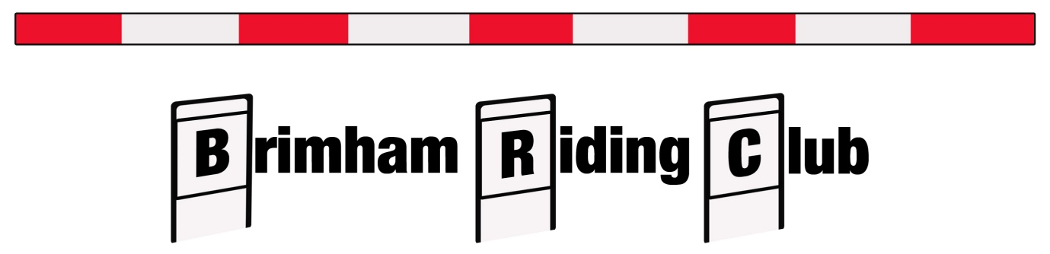
ANNUAL QUIZ
ON
SATURDAY 23RD February 2019
AT
RIPLEY TOWN HALL
STARTING AT 7.30pm

£8.00 per head to include a hot supper.
Maximum of 8 per team.
Entries via www.horsevents.co.uk
Open to members and non-members. Come and join us for this popular event.

