BSPS AREA 3A WINTER WHP SHOW
Wednesday 31st March 2021
NORTHALLERTON EQUESTRIAN CENTRE DL7 0PQ
Enter Online ONLY via link below
https://bspsarea3a.com/schedules#0831eb5d-26dd-4413-9ed8-c70f0c6094d7

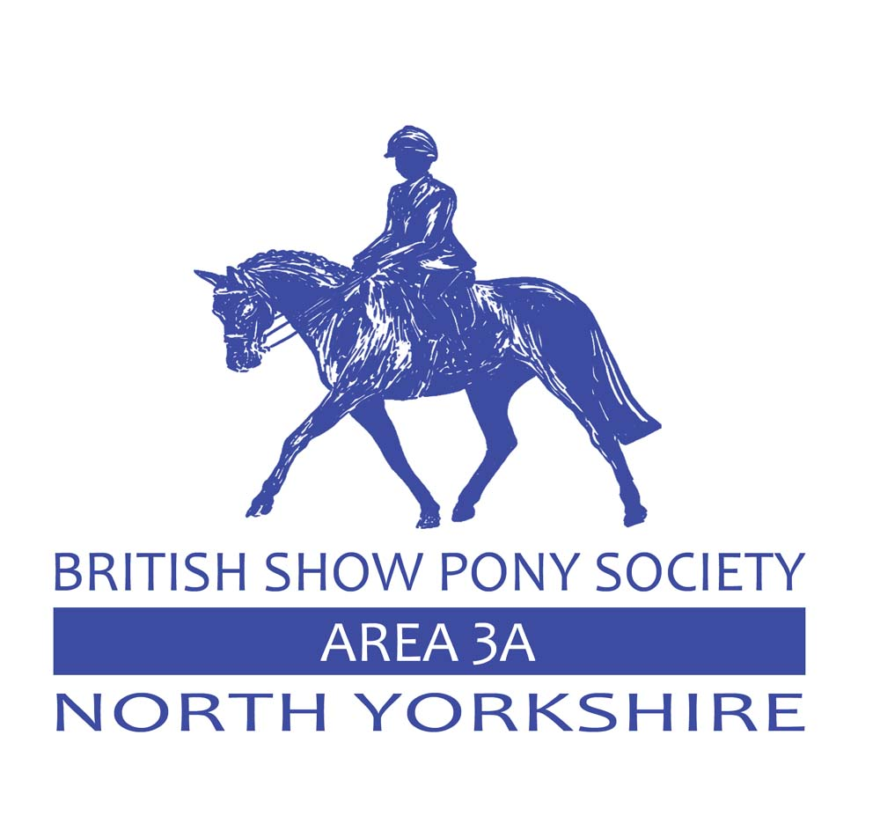
YOU DO NOT HAVE TO BE A MEMBER OF THE BSPS TO COMPETE AT THIS SHOW
BSPS affiliation no:
THIS SHOW WILL STRICTLY FOLLOW BSPS GUIDELINES ALONG WITH GOVERNMENT GUIDELINES WHICH MUST BE FOLLOWED BY ALL COMPETITORS!

Ring 1 Outside– 8.30 am start JUDGE: Mrs J Jefferson
WORKING HUNTER - Body protectors must be worn

Class 1 Lead Rein Working hunter pony - Plaited or unplaited, not exceeding 122cms Riders 9 years and under.

Class 2 Tiny Tots Starter Stakes – plaited or unplaited, pony, 122cms s and under, Riders 11 and under. Max height 40cm.

Class 3 Training Stakes - fences not to exceed 60cms.

Class 4 BSPS Cradle Stakes - Mare or Gelding 4 years old and over not exceeding 122cms. Riders not to have attained their 11th birthday before 1 January in the current year.
Class 5 BSPS Novice Nursery Stakes – not exc 133cms – Riders not to have attained their 12th birthday before 1st January in the current year.

Class 6 BSPS Open (Restricted) Nursery Stakes - not exc 133cms. Riders not to have attained their 12th birthday before 1st January in the current year.
MINI WHP CHAMPIONSHIP 1st and 2nd from classes 4– 6

Class 7 Training Stakes - fences not to exceed 80cms.

Class 8 BSPS Mixed height Novice WHP/WH - Mare or gelding 4 yrs. old and over, not exceeding 158cms. Riders must jump in the correct height section and be the correct age for the height of the animal they ride. Riders may ride more than one Height. Riders must declare if there are jumping in the 153 or 158 section.

Class 9 BSPS Mixed height Open (Restricted) WHP/WH - Mare or gelding 4 yrs. old and over not exceeding 158cms Riders must jump in correct height section and be correct age for the height of the animal they ride. Riders may ride more than one height. Riders must declare if they are jumping the 153 or 158 section.

Heritage WHP Classes Judge: Mr J Harforth

Class 10 BSPS Heritage Mountain and Moorland Cradle Stakes - Registered pure bred ponies 4 years old and over not exceeding 122cms Suitable to be ridden by a rider not to have attained their 11th birthday before 1st January in the current year.
Class 11 BSPS Heritage Mountain and Moorland Nursery Stakes - Registered pure bred ponies 4 yrs. old and over not exceeding 133cms, Suitable to be ridden by a rider not to have attained their 13th birthday before 1st January in the current year.

Class 12 BSPS Mixed height Novice Heritage Mountain and Moorland WHP - Pure bred ponies 4 yrs. old and over. Riders any age

Class 13 BSPS Mixed height (Restricted) Open Heritage Mountain and Moorland WHP - Pure bred ponies 4 yrs. old and over. Riders any age.
Championship 1st and 2nd from classes 10 - 13

Rules and Regulations
- The committee will not be responsible for or be liable for any loss or damage sustained by the exhibitors, riders or their horses or ponies and all entries are accepted on this basis.
- The organizer reserves the right to cancel or amalgamate any classes if there are insufficient entries.
- This show is affiliated to the BSPS and all persons competing or otherwise taking part are subject to the constitution and rules of the BSPS including disciplinary procedures and shall be deemed to have consented to the jurisdiction of the BSPS.
- A timetable will be produced once the entries are closed-there will be specific times for each class.

ROSETTES TO 4TH PLACE IN ALL CLASSES. NO PRIZE MONEY

YOU DO NOT HAVE TO BE A MEMBER OF THE BSPS TO COMPETE AT THIS SHOW
TO ADD IN ALL COVID RESTRICTIONS WHEN AGREED
ONLINE ENTRIES ONLY – £15.00 PER CLASS
NO ENTIRES ON THE DAY
ENTRIES CLOSE ON FRIDAY 26TH MARCH 2021.

