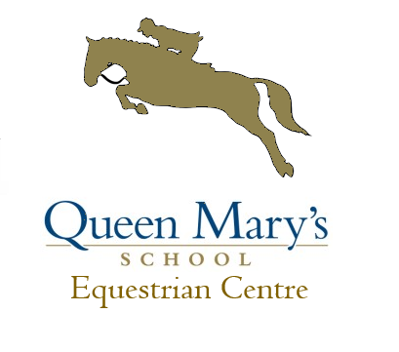
Arena Eventing Competition
Sunday 11th March

Small course of 6 showjumps followed by natural fences with ajump out of arena.
To Commence at 10.00AM, Entries online at Horseevents.co.uk

Approx Start time Entry Fee
1. 70cm £20.00 10.00am £20.00
2. 80cm £20.00 11.00am £20.00
3. 90cm £20.00 12.00pm £20.00

Entries Close 09/03/2018 at 12am, times available online 10/03/2018 or text 07876708943.

Entries online at http://www.horsevents.co.uk/information/eventdetails.asp?event=26512
Or complete the attached entry form and enclose cheque and send to
Queen Mary’s Equestrian Centre,
Queen Mary’s School,
Baldersby Park,
Thirsk,
YO7 3BZ

Rider Name | Horse Name | Class | Amount

Total: ____________

Name:
Address:
Contact Number:
Emergency Contact:
Lorry / Car reg:

Rules
- No responsibility can be accepted for any damage, injury or loss to persons or property whilst attending the event.
- The organisers reserve the right to cancel, alter, split or amalgamate any class depending on entries
- All horses and ponies must be 4 years old and over .
- Hard hats to current BSI standards must be worn at all times whilst mounted and chin straps fastened, body protectors to current standard must also be worn.
- Any person behaving inappropriately will be asked to leave and disqualified
- Please do not leave your litter on the show field- please use the bins provided
- Trailers/lorries are not to be mucked out in the field, horses graze in this field.
- Stallions/ colts will only be allowed by prior arrangement and if over 2yrs old must be suitably bitted
- The judges’ decision is final
- We hope you have fun and enjoy the day.
- The organisers have taken every responsible precaution to ensure the Health and Safety of everyone present at this event. For these measures to be effective, members of the public and competitors alike must take all reasonable precautions to avoid and prevent accidents occurring and must comply with the organisers and all officials and stewards.

