BEDALE HUNT FUN RIDES 2020

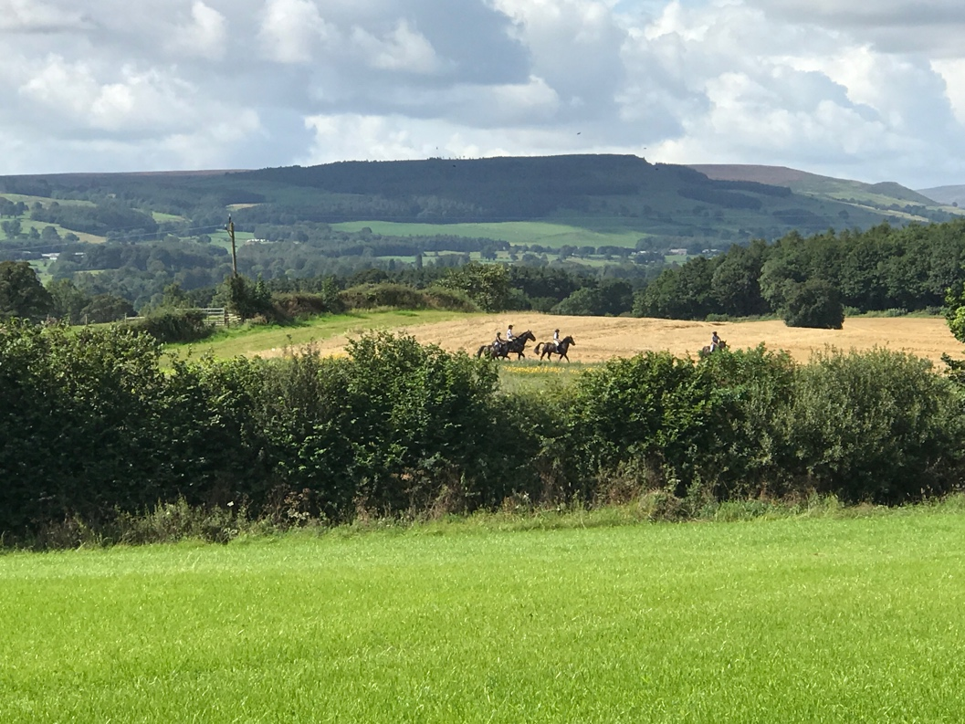

23 August 2020 - Langton Hall, Little Langton, Northallerton, DL7 0PX

31st August 2020 - Knowle House, Kirby Knowle, Thirsk, YO7 2JB

27 September 2020 - Rookwith House Farm, Rookwith, Ripon, HG4 4AY

Another chance to ride across beautiful countryside – grassland, hills, woodland tracks, quiet lanes and along river banks. Enjoy these rides at your own pace. The routes cover approximately 7 to 9 miles of varied terrain. Optional jumps to suit all ages and ability. No dress code.

Starting times between 10am and 12 noon.

There will be a BBQ providing delicious refreshments on your return.

Entry: £20 per adult and £15 for juniors under 16.

Pre-entry only on www.horsevents.co.uk. For further information please e-mail victoriathomas962@gmail.com

