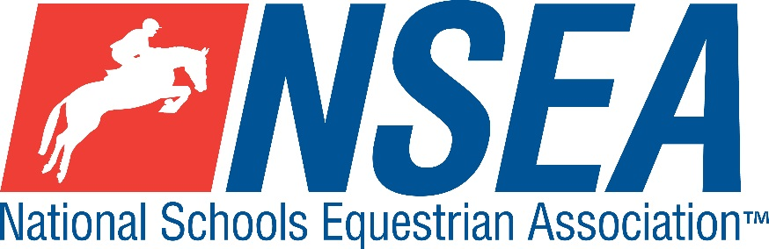

National Schools   
NSEA Arena Eventing Qualifiers  
(Jumping with Style)

Northallerton EC

16th May 2021

PLEASE ENTER ON [www.northallertonequestriancentre.co.uk](http://www.northallertonequestriancentre.co.uk)

1st & 2nd placed team & 1-4th placed individuals will qualify for the 24th annual   
NSEA National Schools Championships 2021

Addington Manor, October 2021  
  
  
3rd -8th placed team & 5th-8th placed individuals will qualify for the  
NSEA Championship Plate 2021

Keysoe 2021

Entries Close: 7 days before the competition (or earlier if classes are full)

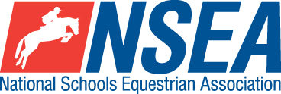

**Rules – NSEA General Rules plus ‘Additional Rules for Qualifiers 2020/21’**

Class 0 Clear Round 65-70cm non Q approx. half the course (£15)

Class 1 Mini 70-75cm Team & Individual Qualifier  
(Riders to be aged under 14 on 1st January 2020)  
All team riders automatically count as individuals.

Class 2 Novice 80-85cm Team & Individual Qualifier

All team riders automatically count as individuals.

Class 3 Intermediate 90-95cm Team & Individual Qualifier.

All team riders automatically count as individuals

Class 4 Open 1m-1.05 Team & Individual Qualifier  
All team riders automatically count as individuals

Class 5ab Advanced 1.10 Individual Qualifier a) horses and b) ponies  
Please state whether you are riding a horse or pony section of the class, as the class will be split.

**Entry Fee £30 incl Paramedic Medical Cover**

**Start Times** will be available on the NSEA website 2 days before the competition [www.nsea.org.uk](http://www.nsea.org.uk)

**Disclaimer… please see www.northallertonequestriancentre.co.uk**

**Your Responsibility***All persons attending the event must take all reasonable precautions to avoid and prevent accidents and must obey instructions given by the Organiser or by officials and stewards on its behalf.*

*All competitors and those associated with their school are the responsibility of the Team Manager whilst at the competition*

The NSEA will not be held responsible for any financial loss incurred by the attendee as a result of a cancellation.

**Child Protection & Safeguarding**  
If you have any concerns, please contact the NSEA on tel 07552 836032 / [competition@nsea.org.uk](mailto:competition@nsea.org.uk) to be put in contact with our designated Child Protection Officer. If you have immediate concerns, you can contact   
Childline tel 0800 1111 or NSPCC tel 0808 800 5000

**TV & Photography**

*Please note that professional photographers will be present at the Qualifiers and there may also be TV cameras at the Championships. Please indicate on the entry form if you do not wish to appear in press coverage/ TV or photos taken by our official photographers*.