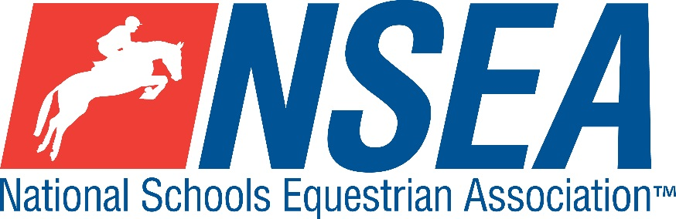
National Schools
NSEA Arena Eventing Qualifiers
(Jumping with Style)
Northallerton EC, March 14th 2020

1st & 2nd placed team & 1-4th placed individuals will qualify for the 24th annual
NSEA National Schools Championships 2020
Addington Manor, October 2020
3rd -8th placed team & 5th-8th placed individuals will qualify for the
NSEA Championship Plate 2020
Keysoe 2020

Entries Close: 7 days before the competition (or earlier if classes are full), book via www.northallertonequestriancentre.co.uk

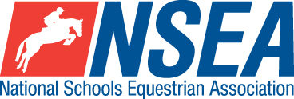

Rules – NSEA General Rules plus ‘Additional Rules for Qualifiers 2020’

Class 1 Mini 70-75cm Team & Individual Qualifier
(Riders to be aged under 14 on 1st January 2020)
All team riders automatically count as individuals.

Class 2 Novice 80-85cm Team & Individual Qualifier
All team riders automatically count as individuals.

Class 3 Intermediate 90-95cm Team & Individual Qualifier.
All team riders automatically count as individuals

Class 4 Open 1m-1.05 Team & Individual Qualifier
All team riders automatically count as individuals

Class 5ab Advanced 1.10 Individual Qualifier a) horses and b) ponies
Please state whether you are riding a horse or pony section of the class, as the class will be split.

Entry Fee £25
Paramedic Medical Cover £3 per rider payable when you collect your numbers
Start Times will be available on the NSEA website 2 days before the competition www.nsea.org.uk

Disclaimer

Except as otherwise stated below [or in our terms and conditions]:
- all participants undertake activities at NSEA events at their own risk. Please ensure that you seek and act upon any appropriate medical advice which you receive before undertaking any activity at NSEA events;
- you are strongly advised to acquaint yourselves with the terms of the NSEA insurance cover which is provided to all registered riders and the team manager of member schools; and
- we will not be liable for any acts or omissions of our employees, agents and sub-contractors in relation to any activity at NSEA events or for any loss or damage suffered by you as a result of taking part in any activity at NSEA events .
All warranties, conditions and other terms implied by statute or common law in relation to any activity at NSEA events are, to the fullest extent permitted by law, excluded. This does not exclude or limit our liability to you for death or personal injury caused by our negligence or any matter for which it would be illegal for us to exclude or attempt to exclude our liability or for fraud or fraudulent misrepresentation.
Notwithstanding the above, NSEA’s total liability (including any liability for the acts or omissions of its employees, agents, consultants and subcontractors) in contract, tort (including negligence or breach of statutory duty), misrepresentation, restitution or otherwise arising in connection with your attendance or participation in any activity at NSEA events shall be limited to £5,000,000.

Your Responsibility
All persons attending the event must take all reasonable precautions to avoid and prevent accidents and must obey instructions given by the Organiser or by officials and stewards on its behalf.
All competitors and those associated with their school are the responsibility of the Team Manager whilst at the competition

Child Protection & Safeguarding
If you have any concerns, please contact the NSEA on tel 07552 836032 / competition@nsea.org.uk to be put in contact with our designated Child Protection Officer. If you have immediate concerns, you can contact
Childline tel 0800 1111 or NSPCC tel 0808 800 5000

TV & Photography
Please note that professional photographers will be present at the Qualifiers and there may also be TV cameras at the Championships. Please indicate on the entry form if you do not wish to appear in press coverage/ TV or photos taken by our official photographers.

