£15.00 per rider booked in advance plus Horsevents booking fee | no refunds.
Pre entry only, strictly no entries on the day – place numbers are limited
Book and pay online: https://horsevents.co.uk/events/?e=36819 and please bring a completed hard copy of this form for each rider to the event, or have with you the necessary information, to complete a hard copy of this form at the event.
Emergency Contact

Name: Contact Number: Relationship:

Vehicle Details

Make: Model: Registration:
Payment
I am over 16 but under 18 and will be riding unaccompanied by an adult ☐

I am over 18 ☐

I am under 16 and will be accompanied by an adult ☐

I confirm that I have read and understood the terms and conditions of entry (tick box) ☐
Signature of Parent or Guardian:

Insurance

All riders must have public liability insurance, valid on the day of the event. BHS Gold Membership includes up to £30 million public liability insurance cover (terms, conditions and territorial limits apply – full details on BHS website) The BHS is an Appointed Representative of South Essex Insurance Brokers Ltd who are authorised and regulated by the Financial Conduct Authority

BHS Gold Membership number and expiry date

Non-BHS Gold Members must provide evidence of cover

Insurance company

Policy No.

Limit of indemnity £

Expiry date

Emergency Contact and vehicle details

Full name:
Address:
Contact No:
Email:

Copgrove Pleasure Ride 2021 - Jubilee Mills, Copgrove, HG3 3TB

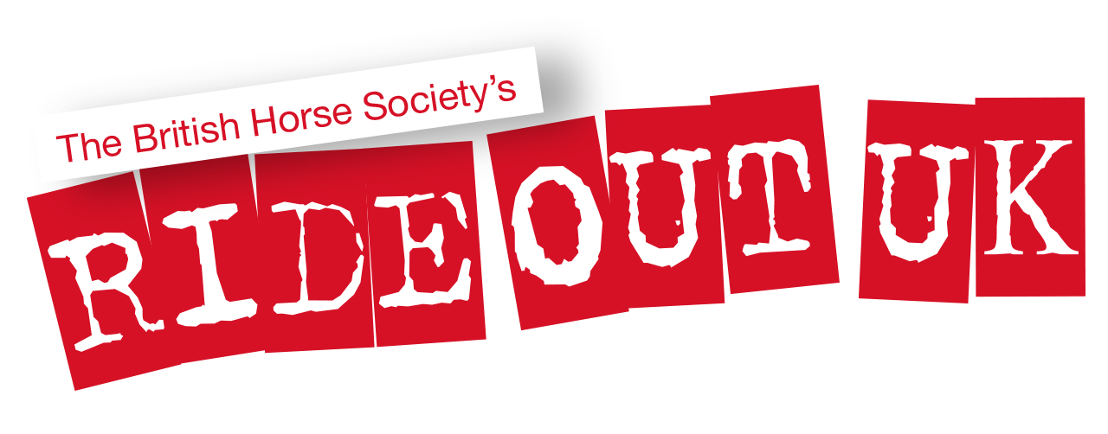
Rider details

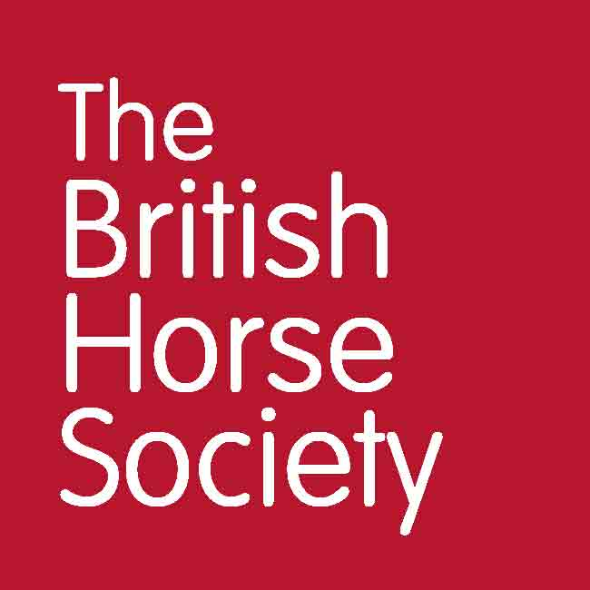
Using your personal information
Permissions

Personal information that you supply to us may be used in a number of ways. For example:
- To contact you about the event
- To promote the event to BHS members and the general public. For example:
  - on The British Horse Society website
  - in British Horse magazine
  - On The British Horse Society social media accounts
- Insurance details for non-members will be kept for seven years in case any insurance claim is brought
- Photographs may be used by The British Horse Society in printed, online or electronic publications, which may be shared publicly. Examples of these materials include, but are not limited to: posters, leaflets, brochures, adverts, emails, e-newsletters, blogs, web pages, social media posts, presentations, speeches, research or policy reports and press releases or other materials.
☐ I agree that photographs of myself may be used by The British Horse Society,
☐ I agree that photographs of the child, for whom I have parental responsibility for, may be used by The British Horse Society.
Date Signed Print

/ /
To see our full Privacy Notice, or if you need any further information, please write to:
The British Horse Society, Abbey Park, Sareton, Kenilworth, Warwickshire, CV8 2XZ
Visit www.bhs.org.uk/privacy
Terms and Conditions
General Rules
- The BHS strongly recommends wearing Hi Viz when riding
- Please report to the organisers on arrival and departure and follow the instructions of marshals and other officials at all times
- All riders are responsible for ensuring the safety of themselves and others
- All riders must have previous experience of riding the horse they have entered into the event
- Always ride with courtesy, care and consideration to fellow users of the route including equestrians, cyclists, walkers, particularly those who may be elderly, disabled, children or simply frightened of horses.
- Ride slowly past other horses and riders
- Do not stray from the planned route or designated areas. Remember horses’ hooves can damage surfaces in wet weather. Leave gates as you find them and ride slowly past all stock
- Ensure the Highway Code is adhered to
- If you return without finishing the ride, for whatever reason, please inform the Organisers and return your ride number
Riders
- Riders under 18 years must be accompanied by a responsible adult for the duration of the event
- Hats to the current standard must be worn and correctly secured at all times when mounted. Please check your hat meets current standards which can be found at www.bhs.org.uk/headwear
- Body protectors are strongly recommended and should comply with current standards – also found on the BHS website at www.bhs.org.uk/bodyprotectors
- All riders must wear suitable riding footwear. Wellington boots and trainers are not allowed
- Riders are advised to carry a mobile phone and be aware of the emergency contact number
Your Horse
- Stallions must display a Stallion Disc at all times.
- All horses must be over the age of four years and of appropriate fitness level for the activity being undertaken – hooves and shoes must be in good condition
- Tack must be in safe condition and fit correctly
- It is a legal requirement to have your horses’ passport when travelling to events
- All horses must be up-to-date with equine influenza vaccinations
- The BHS strongly recommends horses not be left unattended when tied to horseboxes
Covid-19
- Bookings will only be accepted with a fully completed online booking form. For the purposes of ‘Test and Trace’, this form will be kept by the event organiser for 21 days.
- All bookings must be paid for in advance in accordance with the schedule. There will be no exchange of money on the day. Bookings will not be accepted on the day.
- Anyone feeling unwell with Covid-19 type symptoms must not attend. Please contact the organiser for a refund.
- Anyone displaying Covid-19 symptoms, however mild, should stay at home. Anyone who has been in contact with someone that is showing symptoms should stay at home. Anyone considered vulnerable should stay at home. Please inform the organiser if you need to withdraw.
- Soft face masks that cover the mouth and nose are permitted but no face shields may be work for mounted activities.
- Riders must print their own rider number and bring this with them. Each rider will be allocated a number when the times are issued. Please identify yourself by the way of a XC bib, medical armband, showing number on your back or an ID tag. This needs to be on the rider in case of an accident. You can also put an identification number on your horse if you wish (this is not compulsory) which could take the form of a bridle number, number on your numnah or an ID tag.
- Sanitiser will be provided at appropriate locations and all attending should make use of it.
- There will be no passport or vaccination checking on the day. The horse’s passport and a current valid annual vaccination certificate have to be available for electronic spot checks prior to the event. Please note: all passports must still travel with a horse as a legal requirement.
- Please park at least 5m apart in the designated parking area.
- Text the event number to declare your arrival.
- Maintain social distancing from others.
- Please adhere to your warm up and starting times.
- There is no Secretary’s area for this event. Each rider will receive a time for arrival and a start time prior to the event.
- When riding, please keep 2m apart at all times. This applies to groups riding together or when passing others.
- All attendees must keep a 2m distance at all times whilst on site and groups of no more than 5.
- Spectators are not allowed under any circumstances.
- Riders can only be accompanied by one other person
- There will be first aid cover. The first aider will have PPE in case they have to break social distancing guidelines.
- Track and trace information will be taken and kept for up to 21 days after the event.
- Numbers on site are restricted to one person per horse plus the rider. Please respect this rule as it will help us to monitor the number of people on site at any one time.
- If a rider has an additional person attending, a contact form must be filled in for this person. This must be emailed to the organiser no later than 24 hours before the activity begins. For the purposes of ‘NHS Test and Trace’, this form will be kept by the event organiser for 21 days. All forms will be stored in accordance with GDPR guidelines.
- Riders will not exceed a group size of 5. Riders travelling together must be from the same household or ‘bubble’.
- No share of equipment between riders.
- Please leave the site as soon as you can.
- Anyone not complying with the event Covid-19 Health and Safety protocol will be asked to leave the site. There are no exceptions to this rule. Any such instances will also be reported to BHS HQ for further consideration if deemed appropriate.
- Please comply with all signage on site.
- Please support the resumption of activities that we have all been waiting for so long. Your co-operation is very much appreciated.
www.bhs.org.uk
- www.facebook.com/TheBritishHorseSociety
- www.twitter.com/britishhorse (@BritishHorse)
Disclaimer
The organisers have taken reasonable precautions to ensure the health and safety of everyone present. For these measures to be effective, everyone must take reasonable precautions to avoid and prevent accidents. Neither the organisers nor the British Horse Society accept responsibility for any accident, injury, loss or illness to horse, rider, spectator or property whilst at this event.

The British Horse Society is a Registered Charity Nos. 210504 and SC038516

