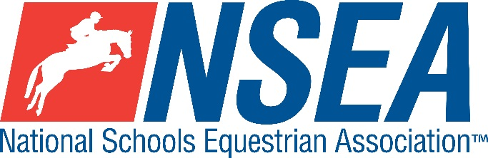

Inter-Schools Dressage

Northallerton EC, Myers Lane, Yafforth, Northallerton, North Yorkshire, DL7 0PQ
Thursday 8th April 2021

County Challenge Dressage Qualifiers & RPL Dressage
(teams & individuals )
- North Yorkshire
- South East & West Yorkshire are 1 x Tri CountyQ
- Co. Durham, Northumberland & Cumbria are 1 x Tri County Q

Note- the highest placed team & individual for the relevant county will be given the title ‘County Champion’
This competition is open to schools from all Counties and will count for RPL points

Entries to: www.northallertonequestriancentre.co.uk

Entries Close: Monday 5th April 2021

Class 1 Warm Up Test - Prelim 7, 30 to 60mins before your other test £12
Class 2 Team & Individual County Qualifier for the County Championships April 2021
Test: Prelim 14 2006 (revised collective marks 2016) – for all riders £15
Teams of 3 or 4, best 3 scores to count.
All team riders also automatically count for individual placings
The winning team & individual from each respective county will represent their county
at the NSEA National County Finals.
The County Dressage Team and Individual Prelim qualifier is open to horse & rider combinations that have not competed at British Dressage Novice level or above. Therefore, horse & rider combinations may compete at BD bronze prelim and silver prelim level and may have gained prelim points. Riders may have also competed at NSEA Novice level, but not Elementary (BD or NSEA).
Class 3 Individual Novice County Qualifier for the County Championships at Hartpury, April 2021
Test: Novice 27 (2007) Individual qualifier only £15
The County Dressage Individual Novice series is open to rider/horse combinations not to have competed at BD Medium level or above or BE Intermediate level. The winning individual from each respective County will represent their County at the NSEA National County Championships.

Disclaimer… (ADD your own show venue disclaimer here)

Your Responsibility
All persons attending the event must take all reasonable precautions to avoid and prevent accidents and must obey instructions given by the Organiser or by officials and stewards on its behalf.
All competitors and those associated with their school are the responsibility of the Team Manager whilst at the competition
All enquiries are to be made by the Team Manager please.

TV & Photography
Please note that professional photographers will be present at NSEA competitions. There may also be TV cameras at the Championships. Please indicate on the entry form if you do not wish to appear in press coverage/ TV or photos taken by our official photographers

Child Protection & Safeguarding
If you have any concerns, please contact the NSEA on tel 07552 836032 / competition@nsea.co.uk to be put in contact with our designated Child Protection Officer. If you have immediate concerns, you can contact
Childline tel 0800 1111 or NSPCC tel 0808 800 5000

General information
Please ensure that you do not muck out your horsebox onto the Car Park. Take all litter home with you.
All dogs must be kept on leads at all times. Any dog mess must be cleared up.

Outside assistance will not be tolerated- and could result in elimination.
NSEA affiliated competitors only may warm up & compete horses on the show ground

All competitions, parents and representatives from every school must ensure that they act courteously to stewards and officials at all times. Most of them are volunteers and rudeness is not acceptable.

In the event of cancellation, you entry will be refunded on receipt of a sae, less £5 per cheque admin fee.
Have a good day!

Rules
NSEA General Rules 2020-21
Note- NSEA Rules- hair up please.

Start Times will be available on the NSEA website 2 days before the competition www.nsea.org.uk

