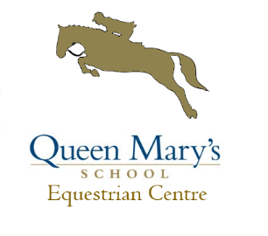
UNAFFILIATED DRESSAGE
SUNDAY 27th January
Start approx. 10am

- INTRO A (2008)
- PRELIM 1 (2006)
- PRELIM 7 (2002)
- NOVICE 24 (2010)

This Competition forms part of a series to be held 26th Jan, 24th Feb, 17th March, 14th July, 4th August, 25th August. Rosettes to 6th place on the day and a points table will be kept with prizes for the overall winners provided by Saracen Horse Feeds to be presented at the final competition of the year on the 4th August 2019.

Entries £10 per class and classes will be split junior and senior if entries warrant. All tests performed on all weather arena, parking available in car park. Competition run under BD rules.

Entries Close 24/01/2019 at 6pm, times available online Saturday 26/01/2019 or text 07876708943.

Entries online at
Or complete the attached entry form and enclose cheque and send to
Queen Mary’s Equestrian Centre,
Queen Mary’s School,
Baldersby Park,
Thirsk,
YO7 3BZ

Cheques payable to Queen Mary’s School.

Rider Name | Horse Name | Class | Amount

Total: ____________

Name:
Address:
Contact Number:
Emergency Contact:
Lorry / Car reg:

