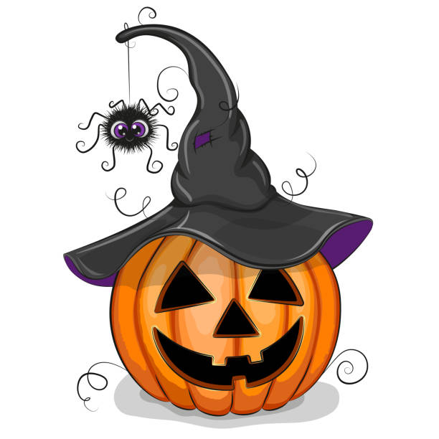
Spooktacular Showjumping
Upsall Grange Equestrian Centre
30TH October
10am Start
Class 1. Creepy Cross Poles
Class 2. Cheeky Pumpkins 60cm
Class 3. Wicked Wizards 70cm
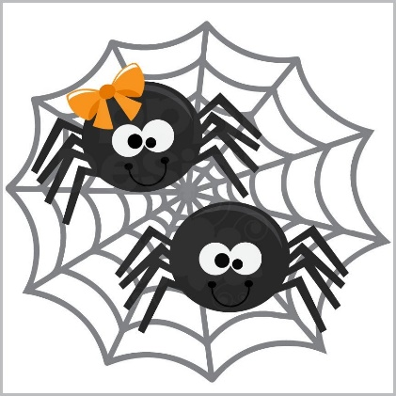
Class 4. Scary Skeletons 80cm
Class 5. Galloping Ghouls 90cm
Class 6. Headless Horsemen 1m
£10 per class or £15 for two classes
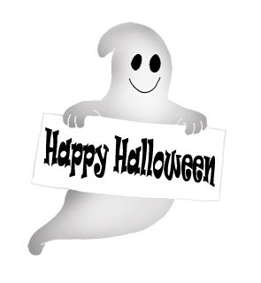
Dress Code - Halloween
Enter via Horseevents
Rosettes to 6th place
Catering van will be onsite

