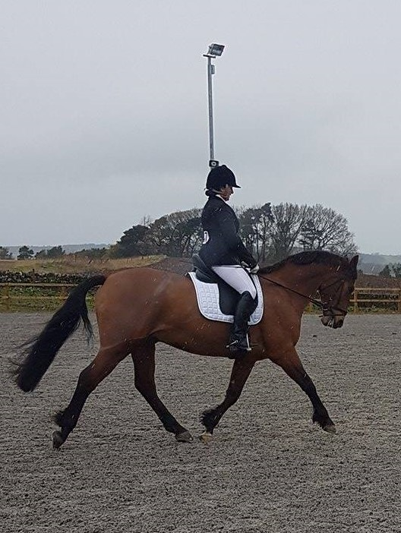
Lanark Riding Club

Long Arena Dressage Test Riding Practice

Venue: West Kype Farm, Strathaven ML10 6PR

Dates: Saturday 30 September 2017

Time: 10.00 - 14.00

Cost: £17.50/member for 30 min session

(May be open to non-LRC members at a £5 surcharge, but priority will be given to LRC members)

Emma Mackie and Katy Westmore will be on hand to help you navigate your way round a 20 x 60 m dressage arena and offer some advice on what the judge is looking for. This would be great preparation for our final dressage competition of the year at Stanmore (Sunday 8 October 2017), where double points will be on offer. The long arena tests which will be used on that day are Prelim 15 (Open class), Novice 37 and Elementary 40 (note that short arena test will be used for Intro and Beginner’s Prelim classes).

Please complete the booking form and email to lanarkridingclub@gmail.com , who will confirm availability and payment details. Spaces are limited and will only be confirmed on receipt of payment.

Booking Form
Terms and Conditions
- Times will be emailed on Thursday evening before the event.
- LRC and West Kype accept no liability for accidents, damage, injury or loss to horses, owners, spectators or property whatsoever and entries are only accepted under this condition.
- Cancellations at the discretion of LRC Committee.
- There may be a photographer in attendance. Photographs taken may be used on the LRC website and in LRC newsletters. If you do not wish your photograph or your child’s photograph to be taken please indicate this on your entry.
- Save for death or personal injury caused by negligence, neither the organisers on the day, nor Lanark Riding Club, accept any liability for any accident, damage, injury or illness to horses, owners, riders, ground spectators or other person or property whatsoever.
- All participants must have evidence of third party liability insurance available for inspection. Members of British Riding Clubs and Gold Card BHS members have this as part of their membership.
- Children must be accompanied by an adult at all times.
- All participants must ensure that their riding hat conforms with current BRC standards. www.bhs.org.uk/enjoy-riding/british-riding-clubs/brc-downloads
- Riders are responsible for lifting any muck which their horse “deposits” and will be excluded from future events if found to not to comply with this condition.

Please note we will try to accommodate your preferences but it depends on us being able to fill the spaces.

I have read the terms and conditions and agree to abide by them, as indicated as a condition of my entry.

Name:
Address:
Mobile no:
email:
LRC Member: Yes/no (delete as appropriate)
Preferred time slot: 10.00, 10.30, 11.00, 11.30, 12.00, 12.30, 13.00, 13.3
(delete as appropriate)

