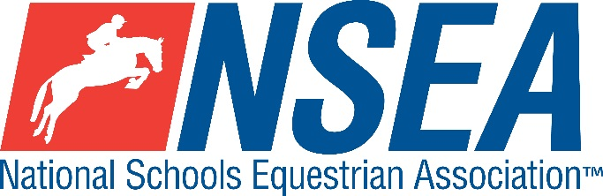

Inter-Schools Show Jumping
NSEA County SJ Qualifiers

NORTHALLERTON EC – 1st & 2nd April 2021

Thursday 1st April
- North Yorkshire Schools ONLY
Friday 2nd April
- South/East/West Yorkshire are 1 x Tri County
- Durham Northumberland Cumbria are 1 x Tri County

Note- the highest placed team & individual for the relevant county will be given the title ‘County Champion’
This competition is open to schools from all counties and will count for RPL points
The winning team & individual will represent their county at the finals
Entries to: www.northallertonequestriancentre.co.uk

Entries Close : Sunday 28th March 2021

Class 1 Mini 70cm Team & Individual County Qualifier
Team & Individual Qualifier for the County finals, April 2021
Class 2 Novice 80cm Team & Individual County Qualifier
Team & Individual Qualifier for the County finals, April 2021
Class 3 Intermediate 90cm Team & Individual County Qualifier
Team & Individual Qualifier for the County Finals, April 2021
Class 4 1m Team & Individual County Qualifier
Team & Individual Qualifier for the County Finals, April 2021

Class 5ab 1.10m Individual County Qualifier. Class split into a) horses and b) ponies
for the County Finals, April 2021

Entry Fee: £15.00 including Paramedic First Aid Cover

Disclaimer see www.northallertonequestriancentre.co.uk

Your Responsibility
All persons attending the event must take all reasonable precautions to avoid and prevent accidents and must obey instructions given by the Organiser or by officials and stewards on its behalf.
All competitors and those associated with their school are the responsibility of the Team Manager whilst at the competition
All enquiries are to be made by the Team Manager please.

TV & Photography
Please note that professional photographers will be present at NSEA competitions. There may also be TV cameras at the Championships. Please indicate on the entry form if you do not wish to appear in press coverage/ TV or photos taken by our official photographers

Child Protection & Safeguarding
If you have any concerns, please contact the NSEA on tel 07552 836032 / competition@nsea.co.uk to be put in contact with our designated Child Protection Officer. If you have immediate concerns, you can contact
Childline tel 0800 1111 or NSPCC tel 0808 800 5000

General information
Please ensure that you do not muck out your horsebox onto the Car Park. Take all litter home with you.
All dogs must be kept on leads at all times. Any dog mess must be cleared up.

Outside assistance will not be tolerated- and could result in elimination.
NSEA affiliated competitors only may warm up & compete horses on the show ground

All competitions, parents and representatives from every school must ensure that they act courteously to stewards and officials at all times. Most of them are volunteers and rudeness is not acceptable.

In the event of cancellation, you entry will be refunded on receipt of a sae, less £5 per cheque admin fee.
Have a good day!

Rules
NSEA General Rules 2020-21
Note- NSEA Rules- hair up please.

Start Times will be available on the NSEA website 2 days before the competition www.nsea.org.uk

