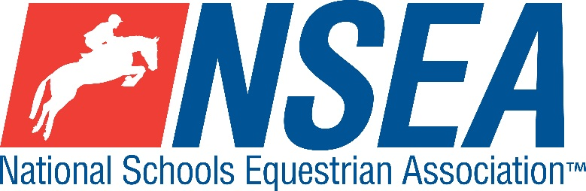

NSEA Eventers Challenge

Northallerton EC, Myers Lane, Yafforth, Northallerton, DL7 0PQ
DATE 19th Dec 2020
Including
70, 80, 90 & 1m qualifying classes for the
NSEA Eventers Challenge Final @ Hickstead May 2021

This competition is open to schools from all counties and will also count for RPL points

Organiser: Tina Walker

Entries to: www.northallertonequestriancentre.co.uk

Entries Close Wednesday 16th Dec unless previously full

Winter Eventers Challenge 2020/2021202020
The course is made up of SJ & simulated XC fences with an optimum time & no style marks. Larger arenas may use secured XC portables. Riders will jump a series of show jumps and then proceed immediately into the XC phase which is run on an optimum time of 325- 375m/m.

Class 1 Mini 70-75cm Team & Individual (Hickstead qualifier)
Single phase. All team riders automatically count as individuals.
Class 2 Novice 80-85cm Team & Individual (Hickstead qualifier)
Single phase. All team riders automatically count as individuals.
Class 3 Intermediate 90-95cm Team & Individual (Hickstead qualifier)
Single phase. All team riders automatically count as individuals
Class 4 1m-1.05 Open Team & Individual (Hickstead qualifier)
Single phase. All team riders automatically count as individuals

Teams of 3 or 4, best 3 scores to count
Entry Fee for classes 1 -4 = £30 per rider per round
Paramedic First Aid Cover included.
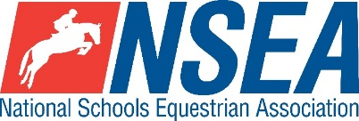
Jumping penalties are awarded as follows….
Knockdown (to include SJ and a few xc fences) | 4 penalties
1st Refusal | 4 penalties
2nd Refusal | 8 penalties
3rd Refusal | Elimination
1st Rider Fall | Elimination
Horse Fall | Compulsory Retirement
Starting before the bell /Retaking an obstacle already jumped/ Error of course | Elimination
Every commenced second over or under the optimum time | 1 penalty
Exceeding time limit (3 times the time allowed) | Elimination
Speed 325-375 metres / minute. No stopwatches allowed.
Body protectors are compulsory. Hair must be above collar length, long hair to be kept in place in a hair net. Crash hats, no fixed peak SJ hats.

In the event of a tie, the competitor closest to the optimum time will be the winner. If teams are tied, the times of the 3 best scores closest to the optimum time will be the winner. Team Managers- Coronavirus Protocols
Please ask parents of every rider to undergo the following brief health check prior to leaving home in order to help us to minimise the spread of Coronavirus. Help us to protect the sport we love.
1. Make sure that all competitors and their families are not breaching lockdown quarantine measures. If anyone within the household of a rider who is competing shows any symptoms of coronavirus, please stay home.
2 The attending parent needs to undertake a brief health check on the morning of the competition.
- Take the temperature of everyone planning to attend the competition
- Has anyone suffered from a persistent cough, loss of taste or smell or have a fever / temperature?
- If anyone has a temperature over 37.8, the household should seek advice and must not attend the competition.
3 Make sure that you have allocated an adult in charge of your squad social distancing, who familiarises themselves with one way systems & protocols at the venue. They will need to keep reminding everyone as it is easy to forget both on and off the horse. It is important that we keep everyone in small groups or ‘bubbles’ and KEEP YOUR DISTANCE, so please follow show centre instructions.
4 Don’t forget your hand sanitiser (use it on arrival at the venue) & PPE. Venues are providing hand sanitiser, but if there are shortages, they could run out. Teams need to be prepared, if this happens. There will also be hot water, soap & hand towels available in bathrooms.
5 If anyone becomes unwell at the event, isolate them & the party they travelled with away from the rest of the riders and seek medical help. Paramedics are in attendance at NSEA events.
6 Limit numbers of personnel. No spectators at events. One parent per competitor where possible.
7 Please do not stay longer than necessary at the competition. ARRIVE, COMPETE, LEAVE, in order to minimise numbers on site at any time. All results will be available online.
8 Social Media. Some parts of the press have questioned the relevance of equestrian sport during this time of coronavirus. Be careful what your squad- parents and riders, post on social media in order to help us to protect our sport.
ARRIVE, COMPETE, LEAVE, in order to minimise numbers on site at any time. Keep your distance and help us to protect the sport we love.

Disclaimer can be viewed on www.northallertonequestriancentre.co.uk

Your Responsibility
All persons attending the event must take all reasonable precautions to avoid and prevent accidents and must obey instructions given by the Organiser or by officials and stewards on its behalf.
All competitors and those associated with their school are the responsibility of the Team Manager whilst at the competition

TV & Photography
Please note that professional photographers will be present at NSEA competitions. There may also be TV cameras at the Championships. Please indicate on the entry form if you do not wish to appear in press coverage/ TV or photos taken by our official photographers

Child Protection & Safeguarding
If you have any concerns, please contact the NSEA on tel 07552 836032 / competition@nsea.co.uk to be put in contact with our designated Child Protection Officer. If you have immediate concerns, you can contact
Childline tel 0800 1111 or NSPCC tel 0808 800 5000

General information
Please ensure that you do not muck out your horsebox onto the Car Park. Take all litter home with you.
All dogs must be kept on leads at all times. Any dog mess must be cleared up.

Outside assistance will not be tolerated- and could result in elimination.
NSEA affiliated competitors only may warm up & compete horses on the show ground

All competitions, parents and representatives from every school must ensure that they act courteously to stewards and officials at all times. Rudeness will not be tolerated.

In the event of cancellation, you entry will be refunded on receipt of a sae, less £5 per cheque admin fee.
Have a good day!

Rules
NSEA / BE Eventing Rules for tack & rider equipment.
NSEA General & Competition Rules 2019-20
Note- NSEA Rules- hair up please.

Start Times will be available on the NSEA website 2 days before the competition on www.northallertonequestriancentre.co.uk www.nsea.org.uk

