 | NVRC Combined Training  Saturday 9th September 2017 | 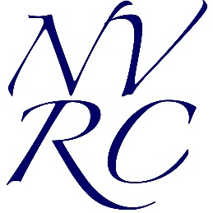

Acrecliffe Equestrian Centre, Ellar Ghyll,
Bradford Road, Otley, LS21 3DN

NVRC members £15, Non-members £20
Entries close Monday 4th Sept.
All entries via Horsevents: http://www.horsevents.co.uk
Times available on NVRC website Thursday 7th September.
Fantastic prizes kindly donated by the sponsor of each class.

Commence 2pm
Class 1 - Sponsored by Propower Saddles
Dressage Prelim 4 Show jumping 60cm

Class 2 - Sponsored by Horse Habits
Dressage Prelim 18 Show jumping 70cm

Class 3 – Sponsored by Wharfedale Equestrian
Dressage Novice 24 Show jumping 80cm

Class 4 – Sponsored by R G Rug Wash Service
Dressage Novice 27 Show jumping 90cm

Dressage warm up on outdoor arena and test indoor arena  Dressage callers permitted  Dressage BD rules | Show jumping on grass, not timed  Show jumping BS rules

Food available on the day
Any questions, contact Allison Knights: ahknights@googlemail.com

