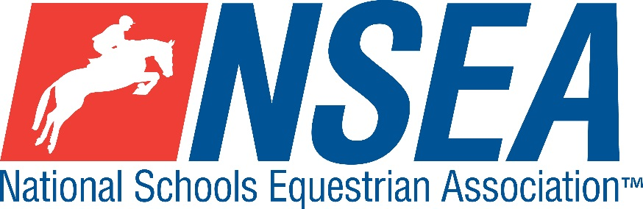

National Schools
NSEA Show Jumping Qualifier
Northallerton Equestrian Centre
27th June 2021

1st & 2nd placed team & 1-4th placed individuals will qualify for the 24th annual
NSEA National Schools Championships 2021
Addington Manor, October 2021
3rd -8th placed team & 5th-8th placed individuals will qualify for the
NSEA Championship Plate 2021
Keysoe 2021

Entries to: www.northallertonequestriancentre.co.uk

Entries Close: 23rd June 2021 £15 per class plus medic fee £3 per rider

Class 1 Mini 70-75cm Team & Individual Qualifier
(Riders to be aged under 14 on 1st January 2020)
Single phase. All team riders automatically count as individuals.

Class 2 Novice 80-85cm Team & Individual Qualifier
Single phase. All team riders automatically count as individuals.

Class 3 Intermediate 90-95cm Team & Individual Qualifier.
Single phase. All team riders automatically count as individuals
Class 4 1m-1.05 Open Team & Individual Qualifier
Single phase. All team riders automatically count as individuals

Class 5a/b 1.10m Advanced Open Individual Qualifier
Single phase. This class will be split into 5a) Horses, 5b) Ponies

Rules- See ‘NSEA Additional Rules for Qualifiers 2021
Start Times will be available on the NSEA website 2 days before the competition www.nsea.org.uk

Team Managers- Coronavirus Protocols
Please ask parents of every rider to undergo the following brief health check prior to leaving home in order to help us to minimise the spread of Coronavirus. Help us to protect the sport we love.
1. Make sure that all competitors and their families are not breaching lockdown quarantine measures. If anyone within the household of a rider who is competing shows any symptoms of coronavirus, please stay home.
2 The attending parent needs to undertake a brief health check on the morning of the competition.
- Take the temperature of everyone planning to attend the competition
- Has anyone suffered from a persistent cough, loss of taste or smell or have a fever / temperature?
- If anyone has a temperature over 37.8, the household should seek advice and must not attend the competition.
3 Make sure that you have allocated an adult in charge of your squad social distancing, who familiarises themselves with one way systems & protocols at the venue. They will need to keep reminding everyone as it is easy to forget both on and off the horse. It is important that we keep everyone in small groups or ‘bubbles’ and KEEP YOUR DISTANCE, so please follow show centre instructions.
4 Don’t forget your hand sanitiser (use it on arrival at the venue) & PPE. Venues are providing hand sanitiser, but if there are shortages, they could run out. Teams need to be prepared, if this happens. There will also be hot water, soap & hand towels available in bathrooms.
5 If anyone becomes unwell at the event, isolate them & the party they travelled with away from the rest of the riders and seek medical help. Paramedics are in attendance at NSEA events.
6 Limit numbers of personnel. No spectators at events. One parent per competitor where possible.
7 Please do not stay longer than necessary at the competition. ARRIVE, COMPETE, LEAVE, in order to minimise numbers on site at any time. All results will be available online.
8 Social Media. Some parts of the press have questioned the relevance of equestrian sport during this time of coronavirus. Be careful what your squad- parents and riders, post on social media in order to help us to protect our sport.
ARRIVE, COMPETE, LEAVE, in order to minimise numbers on site at any time. Keep your distance and help us to protect the sport we love.

Disclaimer… (ADD your own show venue disclaimer here)

Your Responsibility
All persons attending the event must take all reasonable precautions to avoid and prevent accidents and must obey instructions given by the Organiser or by officials and stewards on its behalf.
All competitors and those associated with their school are the responsibility of the Team Manager whilst at the competition
The NSEA will not be held responsible for any financial loss incurred by the attendee as a result of a cancellation.
Child Protection & Safeguarding
If you have any concerns, please contact the NSEA on tel 07552 836032 / competition@nsea.co.uk to be put in contact with our designated Child Protection Officer. If you have immediate concerns, you can contact
Childline tel 0800 1111 or NSPCC tel 0808 800 5000

TV & Photography
Please note that professional photographers will be present at the Qualifiers and there may also be TV cameras at the Championships. Please indicate on the entry form if you do not wish to appear in press coverage/ TV or photos taken by our official photographers.

