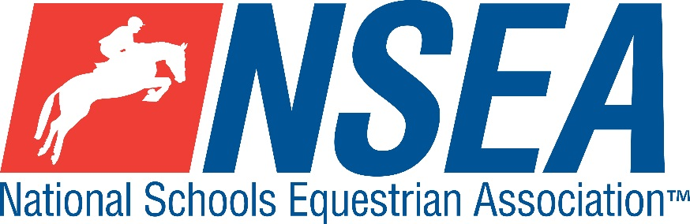

National Schools
NSEA Show Jumping Qualifier
Northallerton EC 7th April 2024

1st & 2nd placed team & 1-4th placed individuals will qualify for the 26th annual
NSEA National Schools Championships 2024
October 2023
3rd -8th placed team & 5th-8th placed individuals will qualify for the
NSEA Championship Plate 2024
October 2024

Includes Hickstead Elite
Show Jumping Qualifiers 2024

Entries to: www.northallertonequestriancentre.co.uk

Entries Close 1 week before event unless full

£18 per class

Class GrassRoots 50cm /Warm Up non national qualifier, (including Grass Roots Qualifier for eligible riders)

Class GrassRoots 60cm /Warm Up non national qualifier, (including Grass Roots Qualifier for eligible riders)

Class 1 Mini 70-75cm Team & Individual Qualifier
(Riders to be aged under 14 on 1st January 2024)
Single phase. All team riders automatically count as individuals.

Class 2 Novice 80-85cm Team & Individual Qualifier
Single phase. All team riders automatically count as individuals.

Class 3 Intermediate 90-95cm Team & Individual Qualifier.
Single phase. All team riders automatically count as individuals
Class 4 1m-1.05 Open Team & Individual Qualifier
Single phase. All team riders automatically count as individuals

Class 5a/b 1.10m Advanced Open Individual Qualifier
( 2 x horses and 2 x ponies to qualify)
Single phase. This class will be split into 5a) Horses, 5b) Ponies

Hickstead Elite 1m Team & Individual Qualifier 2024
Teams of 3 or 4, best 3 scores to count. 1 round, single phase.
1 metre Final 25-27 May 2024

Hickstead Elite 1.10 Individual Qualifier 2024
Individual 1.10m qualifiers for section a) 2 x horses and section b) 2 x ponies (separate sections)
Distances will be shortened in combinations for the pony section.
1 round single phase.
1.10 Individual final 28th June 2024

Rules- See ‘NSEA Additional Rules for Qualifiers 2023-24
Start Times will be available on the NSEA website 2 days before the competition www.nsea.org.uk

Disclaimer see www.northallertonequestriancentre.co.uk

Your Responsibility
All persons attending the event must take all reasonable precautions to avoid and prevent accidents and must obey instructions given by the Organiser or by officials and stewards on its behalf.
All competitors and those associated with their school are the responsibility of the Team Manager whilst at the competition
The NSEA will not be held responsible for any financial loss incurred by the attendee as a result of a cancellation.
Child Protection & Safeguarding
If you have any concerns, please contact the NSEA on tel 07552 836032 / competition@nsea.co.uk to be put in contact with our designated Child Protection Officer. If you have immediate concerns, you can contact
Childline tel 0800 1111 or NSPCC tel 0808 800 5000

TV & Photography
Please note that professional photographers will be present at the Qualifiers and there may also be TV cameras at the Championships. Please indicate on the entry form if you do not wish to appear in press coverage/ TV or photos taken by our official photographers.

