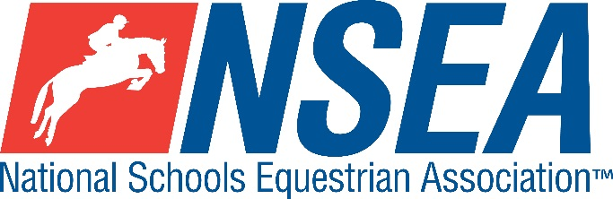

**Inter-Schools County Dressage**

**@ Northallerton Equestrian Centre**

*Sunday 5th January 2025*

**County Challenge Dressage Qualifiers for North/East/West Yorkshire, County Durham, Northumberland and & RPL Dressage open to all  
(teams & individuals)**

**The highest placed team & individual for the relevant county will be given the title ‘County Champion’**

**Team & Individual County Qualifiers for the County Championships at Hickstead, May 2025**

At the Inter- County finals, each county will be represented by the following horse/rider combinations who have qualified in this competition:   
 1 x Prelim Restricted Rider

1 x Prelim Open Rider   
1 x Novice Rider   
1 x Restricted Team   
1 Open Team   
All team riders automatically count as individuals. Placings are not passed down.

Entries to: http://www.northalleronequestriancentre.co.uk/

Entries Close: see Northallerton’s website

Please state county on the entry

**Class 1 Warm up test Prelim 1 £15**

Approx 30 mins before your Prelim 2 test

Team Qualifiers

**Teams** (of 3 or 4 with the best 3 percentage scores to count) **A horse/rider combination may only compete in one team.**

**Class 2 County Prelim Teams** **£18**  
open to 3/4 x prelim riders that have never ridden above BD bronze prelim level, any novice level dressage (affiliated or unaffiliated,) open pony club or novice BE eventing.

**Test:** **Prelim 2 (2024)**

The winning team from each respective county will represent their county

at the NSEA Inter County Finals.

*(2023 Inter-County Prelim Team Champions- King’s Macclesfield, Cheshire)*

**Class 3 County Open Teams** **£18**

(2 x prelim riders & 2 x novice riders)

Prelim section is open to horse & rider combinations that have not competed at British Dressage Elementary level or above. Novice section is open to all.

Teams of 3 / 4 riders, best 3 percentage scores to count

**Test:** **Prelim 2 (2024)**

**Test: Novice 2 (2024)**

The winner from each respective county will represent their county

at the NSEA Inter County Finals.  
*(2023 Inter-County Open Team Champions – Cranleigh, Surrey)*

Individual Qualifiers (to be run in conjunction with the team tests)

**Class 4 County Individual Prelim Qualifiers £18  
4A** County Prelim Restricted Individual **Prelim 2 (2024)**– Rider to have only competed at prelim level

**4B** County Prelim Open Individual **Prelim 2 (2024)** – open to horse/ rider combinations who have not competed at Elementary level or above or BE Intermediate level.

**Class 5 County Individual Novice Qualifiers** **£18  
Test: BD Novice 2 (2024)**

Open to rider/horse combinations not to have competed at BD Medium level or above or BE Intermediate level.

**The winning individual from each respective county individual class will represent their county at the NSEA Inter County Finals. (one per county only)  
If there are two sections per class, a ride off will determine the result.**

**Disclaimer, please see www.northallertonequestriancentre.co.uk**

**Your Responsibility**All persons attending the event must take all reasonable precautions to avoid and prevent accidents and must obey instructions given by the Organiser or by officials and stewards on its behalf.

**All competitors and those associated with their school are the responsibility of the Team Manager whilst at the competition**

**All enquiries are to be made by the Team Manager please.**

**TV & Photography**Please note that professional photographers will be present at NSEA competitions. There may also be TV cameras at the Championships. Please indicate on the entry form if you do not wish to appear in press coverage/ TV or photos taken by our official photographers

**Child Protection & Safeguarding**  
If you have any concerns, please contact the NSEA on tel 07552 836032 / [competition@nsea.co.uk](mailto:competition@nsea.co.uk) to be put in contact with our designated Child Protection Officer. If you have immediate concerns, you can contact   
Childline tel 0800 1111 or NSPCC tel 0808 800 5000

**General information**

Please ensure that you do not muck out your horsebox onto the Car Park. Take all litter home with you.

All dogs must be kept on leads at all times. Any dog mess must be cleared up.

Outside assistance will not be tolerated- and could result in elimination.

NSEA affiliated competitors only may warm up & compete horses on the show ground

All competitions, parents and representatives from every school must ensure that they act courteously to stewards and officials at all times. Most of them are volunteers and rudeness is not acceptable.

In the event of cancellation, your entry will be refunded on receipt of a sae, less £5 per cheque admin fee.

Have a good day!

**Rules**

**NSEA General Rules 2024-25**

Note- NSEA Rules- hair up please.

**Start Times** will be available on the NSEA website 2 days before the competition [www.nsea.org.uk](http://www.nsea.org.uk)