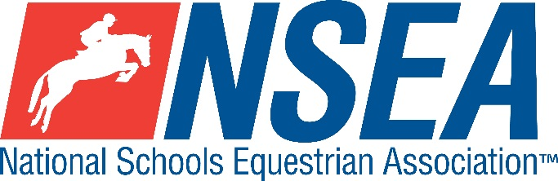

Inter-Schools County Dressage
Northallerton Equestrian Centre
Sunday 18th January 2026
County Challenge Dressage Qualifiers for North, East and West Yorkshire, Co Durham and Northumberland and & RPL Dressage open to all
(teams & individuals)

The highest placed team & individual for the relevant county will be given the title ‘County Champion’
Team & Individual County Qualifiers for the County Championships at Hickstead, May 2026
At the Inter-county finals, each county will be represented by the following horse/rider combinations who have qualified in this competition:
1 x prelim restricted (P1) rider (not to have competed at novice level)
1 x Prelim Open rider (P1)
1 x Novice rider (N2)
1 x restricted team (4 x P1)
1 Open Team ( 2 x P2 & 2 x N2)
All team riders automatically count as individuals. Placings are not passed down.

Entries to: www.northallertonequestriancentre.co.uk

Entries Close: Midnight on Monday 12th 2026 unless FULL where it will close earlier

All tests are the new British Dressage (BD) tests from 2024

Class 0: Warm-up, BD Prelim 3, non-qualifier
Team Qualifiers
Teams (of 3 or 4 and the best 3 percentage scores to count)
A horse/rider combination may only compete in one team.

Class 1 County Prelim Teams
open to 3/4 x prelim riders that have never ridden above BD bronze prelim level, any novice level dressage (affiliated or unaffiliated,) open pony club or novice BE eventing.
Test: BD Prelim 1 (2024)
The winning team from each respective county will represent their county at the NSEA Inter County Finals.
(2024 Inter-County Prelim Team Champions- The Chase School, Worcs)

Class 2 County Open Teams
(2x prelim riders & 2x novice riders)
Prelim section is open to horse & rider combinations that have not competed at British Dressage Elementary level or above. Novice section is open to all.
Teams’ of 3/4 riders, best 3 percentage scores to count
Test: BD Prelim 2 (2024)
Test: BD Novice 2 (2024)
The winner from each respective county will represent their county
at the NSEA Inter County Finals.
(2023 Inter-County Open Team Champions – Mayfield, East Sussex)

Individual Qualifiers (to be run in conjunction with the team tests)

County Individual Prelim Qualifiers
Class 1A: County Prelim Restricted Individual BD Prelim 1 (2024)– Rider to have only competed at prelim level
Class 2B: County Prelim Open Individual BD Prelim 2 (2024) – open to all horse/ rider combinations who have not competed at Elementary level or above or BE Intermediate level.
Class 2C: County Individual Novice Qualifiers BD Novice 2 (2024)- Open to rider/horse combinations not to have competed at BD Medium level or above or BE Intermediate level.
The winning individual from each respective county individual class will represent their county at the NSEA Inter County Finals. (one per county only)
If there are two sections per class, a ride off will determine the result.

Entry Fee: £20 last year (£17 for warm up)
Disclaimer: please see www.northallertonequestriancentre.co.uk

Your Responsibility
All persons attending the event must take all reasonable precautions to avoid and prevent accidents and must obey instructions given by the Organiser or by officials and stewards on its behalf.
All competitors and those associated with their school are the responsibility of the Team Manager whilst at the competition
All enquiries are to be made by the Team Manager please.

TV & Photography
Please note that professional photographers will be present at NSEA competitions. There may also be TV cameras at the Championships. Please indicate on the entry form if you do not wish to appear in press coverage/ TV or photos taken by our official photographers

Child Protection & Safeguarding
If you have any concerns, please contact the NSEA on tel 07552 836032 / competition@nsea.co.uk to be put in contact with our designated Child Protection Officer. If you have immediate concerns, you can contact
Childline tel 0800 1111 or NSPCC tel 0808 800 5000

General information
Please ensure that you do not muck out your horsebox onto the Car Park. Take all litter home with you.
All dogs must be kept on leads at all times. Any dog mess must be cleared up.

Outside assistance will not be tolerated- and could result in elimination.
NSEA affiliated competitors only may warm up & compete horses on the show ground

All competitions, parents and representatives from every school must ensure that they act courteously to stewards and officials at all times. Most of them are volunteers and rudeness is not acceptable.

In the event of cancellation, you entry will be refunded on receipt of a sae, less £5 per cheque admin fee.
Have a good day!

Rules
NSEA General Rules 2025-25
Note- NSEA Rules- hair up please.

Start Times will be available on the NSEA website 2 days before the competition www.nsea.org.uk

