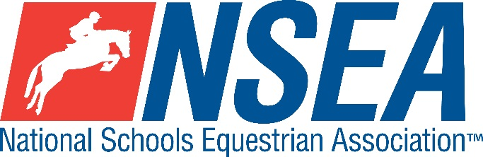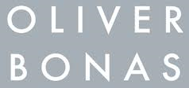

Inter-Schools Show Jumping
Northallerton Equestrian Centre
Sunday 18th January 2026
North, East and West Yorkshire, Co Durham and Northumberland NSEA County Qualifiers
The highest placed team & individual for the relevant county will be given the title ‘County Champion’ and will qualify for the NSEA County Finals at Hickstead May 2026
NSEA Nations Cup Riders for England are selected at the County Finals at Hickstead, for the NSEA Championships at Addington in October
This competition is open to schools from all counties and will count for RPL points.
All classes are single phase.

Entries to: www.northallertonequestriancentre.co.uk

Entries Close: Midnight on Monday 12th 2026 unless FULL where it will close earlier

Class 1: Warm Up 50cm (non-county Qualifier) as well as Grass Roots Qualifier (please specify which section you are in on your entry)
Individual only

Class 2: Warm Up 60cm (non-county Qualifier) as well as Grass Roots Qualifier (please specify which section you are in on your entry)
Individual only

Class 3: Mini 70cm Team & Individual County Qualifier
Team & Individual Qualifier for the County finals
(2025 Inter- County Mini Team Champions Kings, Taunton. Somerset)
Class 4: Novice 80cm Team & Individual County Qualifier
Team & Individual Qualifier for the County finals
(2025 Inter-County Novice team Champions Wellington College, Berks)
Class 5: Intermediate 90cm Team & Individual County Qualifier
Team & Individual Qualifier for the County Finals
(2025 Inter-County Intermediate Team Champions Queen Mary’s, N. Yorkshire)
Class 6: 1m Team & Individual County Qualifier
Team & Individual Qualifier for the County Finals
(2025 Inter-County Open Team Champions Heathfield CC, East Sussex)

Class 7a/b: 1.10m Individual County Qualifier.
Class split into a) horses and b) ponies for the County Finals

Entry Fee: £18
Paramedic First Aid included in the entry fee

Disclaimer: please see www.northallertonequestriancentre.co.uk

Your Responsibility
All persons attending the event must take all reasonable precautions to avoid and prevent accidents and must obey instructions given by the Organiser or by officials and stewards on its behalf.
All competitors and those associated with their school are the responsibility of the Team Manager whilst at the competition
All enquiries are to be made by the Team Manager please.

TV & Photography
Please note that professional photographers will be present at NSEA competitions. There may also be TV cameras at the Championships. Please indicate on the entry form if you do not wish to appear in press coverage/ TV or photos taken by our official photographers

Child Protection & Safeguarding
If you have any concerns, please contact the NSEA on tel 07552 836032 / competition@nsea.co.uk to be put in contact with our designated Child Protection Officer. If you have immediate concerns, you can contact
Childline tel 0800 1111 or NSPCC tel 0808 800 5000

General information
Please ensure that you do not muck out your horsebox onto the Car Park. Take all litter home with you.
All dogs must be always kept on leads. Any dog mess must be cleared up.

Outside assistance will not be tolerated- and could result in elimination.
NSEA affiliated competitors only may warm up & compete horses on the show ground

All competitions, parents and representatives from every school must ensure that they act courteously to always stewards and officials. Most of them are volunteers and rudeness is not acceptable.

In the event of cancellation, see NSEA & Venue refund policy.
Have a good day!

Rules
NSEA General Rules 2025-26
Note- NSEA Rules- hair up please.

Start Times will be available on the NSEA website 2 days before the competition www.nsea.org.uk

HEALTH CHECK BEFORE YOU LEAVE
PRACTISE GOOD HAND HYGIENE

