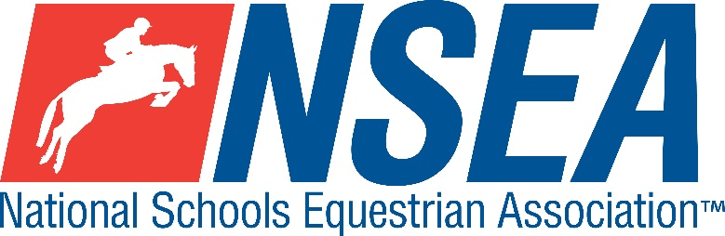

NSEA Eventers Challenge & JWS Super Qualifier

Northallerton EC
Saturday 21st February 2026
Including
This competition is a ‘Super Qualifier’ with Eventers Challenge and JWS qualifications at the same event.
Eventers Challenge Top 2 teams & 4 individuals to qualify for the Championships at the NSEA National Championships at Hickstead in May 2026

JWS Top 2 teams & 4 individuals to qualify for the Championships at the NSEA National Championships at Addington in October 2026

This competition is open to schools from all counties and will also count for RPL points

Organiser: Tina Walker (Northallerton EC)

Entries to: www.northallertonequestriancentre.co.uk

Entries Close 7 days before (earlier if full & daylight is limited in November!)

Eventers Challenge Qualifiers
The Course is made up of SJ & simulated XC fences with an optimum time & no style marks. Larger arenas may use secured XC portables. Riders will jump a series of show jumps and then proceed immediately into the XC phase which is run on an optimum time of 350- 375m/m.
Jumping with Style Qualifiers
Same course , and heights and EC Rules but there will be an additional style mark for JWS placings only, which may result in riders qualifying for one or both championships.

ALL CLASSES £35
Class 0: 60 warm up class (non-qualifier)

Class 1: Mini 70-75cm Team & Individual (Hickstead qualifier)
Single phase. All team riders automatically count as individuals.
Class 2: Novice 80-85cm Team & Individual (Hickstead qualifier)
Single phase. All team riders automatically count as individuals.
Class 3: Intermediate 90-95cm Team & Individual (Hickstead qualifier)
Single phase. All team riders automatically count as individuals
Class 4: 1m-1.05 Open Team & Individual (Hickstead qualifier)
Single phase. All team riders automatically count as individuals

Teams of 3 or 4, best 3 scores to count
Entry Fee for classes 0 -4 = £35
Paramedic First Aid Cover included
Entries close 7 days before (earlier if full & daylight is limited in November!)


NSEA Eventers Challenge Rules for Scoring 2025-26

The intention of these rules is to reward riders who have a clear round and to penalise riders who have jumping penalties or who are significantly faster than the Optimum Time. Where there are several competitors with a clear round, then the nearest to the Optimum Time will win, rewarding an appropriate judgement of pace around the course.

EC1) Open to Teams and Individuals
• Riders will jump a course of 5-8 show jumps and then proceed immediately into the XC phase of 8-15 simulated XC fences, depending on the size of the arena
• The speed for the XC phase will be between 320m/m to 375m/m depending on the size of the arena – smaller arena = tighter turns which slow you down. A larger arena with flowing lines will ride on a quicker time. The speed for each class will be given in the schedule or on the noticeboard at the event. Times will be recorded to one-hundredth of a second if the timing equipment allows.
• NSEA/BE Eventing Rules for tack and rider equipment for XC.
• There will be no style mark. No age restriction on the mini (70/75) class.
• Top two teams and 4 Individuals at each height to qualify for the NSEA Eventers Challenge Championship to be held at Hickstead in May.

EC2) Dress: XC colours, body protectors are compulsory. Hair must be above collar length, long hair to be kept in place in a hair net. Rider must wear BE approved skull caps, no fixed peak SJ hats.

EC3) The competitor with the fewest penalties wins. In the event of a tie, the competitor closest to the optimum time will be the winner. In the team competition, the total of the best three scores is used to place the team. The combined difference from the Optimum Time of the 3 best scores is used to break any ties.

EC4) The top 2 teams & 4 individuals at each qualifier will qualify for the NSEA Eventers Challenge Championship.

EC5) Organisers are asked to ensure that the XC phase includes elements that give a choice about the track and therefore the time taken. Organisers are asked not to display a clock showing the time taken visible to the rider to as the aim is to educate riders to ride by feel.

Penalties are awarded as follows
Knockdown (to include SJ and knockable xc fences) | 4 penalties
1st Refusal | 4 penalties
2nd Refusal | 8 penalties
3rd Refusal | Elimination
Rider Fall | Elimination
Horse Fall | Elimination
Starting before the bell, retaking an obstacle already jumped, error of course or outside assistance | Elimination
Where the Optimum Time is 120 seconds or less, for every commenced second in excess of 10 seconds under the optimum time | 1 penalty
Where the Optimum Time more than 120 seconds, for every commenced second in excess of 15 seconds under the optimum time | 1 penalty
Exceeding time limit (2 times the Optimum Time) | Elimination

Scoring for JWS
EC penalties as above PLUS Style JWS penalties

Disclaimer… (please see www.northallertonequestriancentre.co.uk)

Your Responsibility
All persons attending the event must take all reasonable precautions to avoid and prevent accidents and must obey instructions given by the Organiser or by officials and stewards on its behalf.
All competitors and those associated with their school are the responsibility of the Team Manager whilst at the competition

TV & Photography
Please note that professional photographers will be present at NSEA competitions. There may also be TV cameras at the Championships. Please indicate on the entry form if you do not wish to appear in press coverage/ TV or photos taken by our official photographers

Child Protection & Safeguarding
If you have any concerns, please contact the NSEA on tel 07552 836032 / competition@nsea.co.uk to be put in contact with our designated Child Protection Officer. If you have immediate concerns, you can contact
Childline tel 0800 1111 or NSPCC tel 0808 800 5000

General information
Please ensure that you do not muck out your horsebox onto the Car Park. Take all litter home with you.
All dogs must be kept on leads at all times. Any dog mess must be cleared up.

Outside assistance will not be tolerated- and could result in elimination.
NSEA affiliated competitors only may warm up & compete horses on the show ground

All competitions, parents and representatives from every school must ensure that they act courteously to stewards and officials at all times. Rudeness will not be tolerated.

In the event of cancellation, you entry will be refunded on receipt of a sae, less £5 per cheque admin fee.
Have a good day!

Rules
NSEA / BE Eventing Rules for tack & rider equipment.
NSEA General & Competition Rules 2025-26
Note- NSEA Rules- hair up please.

Start Times will be available on the NSEA website 2 days before the competition on www.nsea.org.uk



