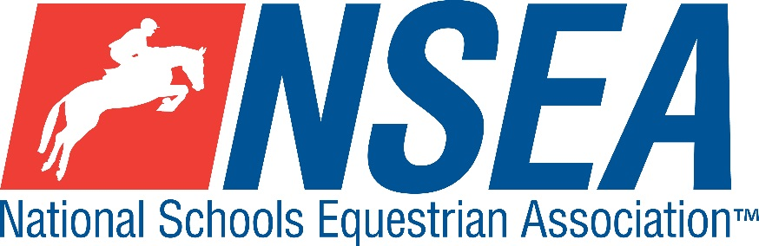

National Schools   
NSEA National Dressage Qualifiers

**Northallerton Equestrian Centre  
20th September 2025**

1st & 2nd placed team & 1-4th placed individuals will qualify for the   
NSEA National Schools Championships 2025

Addington Manor, October 2025

Entries Close: 7 days before the competition (or earlier if classes are full)

DRESSAGE

**Tests at Championship Qualifiers 2024 (Team & Individual) all in 20x40m arenas as follows**

**Class 01** BD Prelim 2 (2024)  
Open to horse & rider combinations that have not competed at British Dressage Elementary level or above  
 **Class 02** BD Novice 2 (2024)  
Horse / rider combinations which have ever competed at Medium level or above may not compete in Novice classes.

However, riders may compete on a different horse.  
 **Class 03** BD Elementary 1 (2024)

No restrictions on horse or rider

**Entry Fee £20 per test**

**Teams**

**Teams shall be made up of 3 or 4 riders (best 3 scores to count) with up to two riders to compete in the prelim test and up to two riders in the novice test.**

**All team riders will automatically count for individual placings providing they are eligible (see NSEA ‘Additional rules)  
The top 2 teams & 4 Individuals will qualify for the Championships  
If there is more than one section, a ride off will determine who qualifies, (or 1 team & 2 individuals per section)**

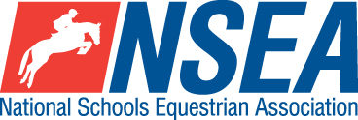

**Rules – NSEA General Rules plus ‘Additional Rules for Qualifiers 2024-25**

**Entry Fee £20  
Start Times** will be available on the NSEA website 2 days before the competition [www.nsea.org.uk](http://www.nsea.org.uk)

**HEALTH CHECK** BEFORE YOU LEAVE

**Disclaimer- see www.northallertonequestriancentre.co.uk**

**Your Responsibility***All persons attending the event must take all reasonable precautions to avoid and prevent accidents and must obey instructions given by the Organiser or by officials and stewards on its behalf.*

*All competitors and those associated with their school are the responsibility of the Team Manager whilst at the competition*

The NSEA will not be held responsible for any financial loss incurred by the attendee as a result of a cancellation.

**Child Protection & Safeguarding**  
If you have any concerns, please contact the NSEA on tel 07552 836032 / [competition@nsea.org.uk](mailto:competition@nsea.org.uk) to be put in contact with our designated Child Protection Officer. If you have immediate concerns, you can contact   
Childline tel 0800 1111 or NSPCC tel 0808 800 5000

**TV & Photography**

*Please note that professional photographers will be present at the Qualifiers and there may also be TV cameras at the Championships. Please indicate on the entry form if you do not wish to appear in press coverage/ TV or photos taken by our official photographers*.



National Schools   
NSEA Combined Training Qualifiers

**Northallerton Equestrian Centre  
20th September 2025**

1st & 2nd placed team & 1-4th placed individuals will qualify for the   
NSEA National Schools Championships 2025

October 2025

Entries Close: 7 days before the competition (or earlier if classes are full)

**Class 04 Combined Training Individual Novice Qualifier**  
Prelim = BD Prelim 1 (2024), SJ 80cm

**Class 05 Combined Training Intermediate Qualifier**Prelim = BD Prelim 1 (2024), SJ 90cm

**Class 06 Combined Training Open Qualifier**

Prelim = BD Prelim 1 (2024), SJ 1m

**Teams:** 3 or 4 riders, jumping at two different heights. Best 3 scores to count.  
1 & 2 Novice Teams (2 x 80 & 2 x 90 riders)   
2 & 3 Open Teams (2 x 90 & 2 x 1m riders)

**Entry Fee £34**

**Start Times** will be available on the NSEA website 2 days before the competition [www.nsea.org.uk](http://www.nsea.org.uk)

**NSEA Rules 2024-25**

For 2025, there will be TWO team mixed height sections and THREE Individual qualifying sections.   
Teams are made up of 3 or 4 riders  
1 Combined Teams Intermediate/ Novice (2 riders jump 80cm and 2 riders jump 90cm)  
2 Combined Teams Open /Intermediate (2 riders jump 90cm and two riders jump 1m)   
Team riders will automatically count as individuals.

All riders will ride the same test BD Dressage Test Prelim 2 (2024) before jumping in 3 height sections 80, 90 and 1m.

**Disclaimer- see www.northallertonequestriancentre.co.uk**

**Your Responsibility***All persons attending the event must take all reasonable precautions to avoid and prevent accidents and must obey instructions given by the Organiser or by officials and stewards on its behalf.*

*All competitors and those associated with their school are the responsibility of the Team Manager whilst at the competition*

The NSEA will not be held responsible for any financial loss incurred by the attendee as a result of a cancellation.

**Child Protection & Safeguarding**  
If you have any concerns, please contact the NSEA on tel 07552 836032 / [competition@nsea.org.uk](mailto:competition@nsea.org.uk) to be put in contact with our designated Child Protection Officer. If you have immediate concerns, you can contact   
Childline tel 0800 1111 or NSPCC tel 0808 800 5000

**TV & Photography**

*Please note that professional photographers will be present at the Qualifiers and there may also be TV cameras at the Championships. Please indicate on the entry form if you do not wish to appear in press coverage/ TV or photos taken by our official photographers*.

**HEALTH CHECK** BEFORE YOU LEAVE

PRACTISE GOOD **HAND HYGIENE**