EASTER SHOW
UPSALL GRANGE EQUESTRIAN CENTRE
APRIL 16TH
10am start prompt.
In-Hand
Class 1. Young Handler
Class 2. Most Handsome Gelding
Class 3. Prettiest Mare
Class 4. Youngstock
Class 5. Thoroughbred
Class 6. Coloured
Class 7. Part Bred
Class 8. Open Horse
Class 9. Veteran
Class 10. M&M
CHAMPIONSHIP
Ridden
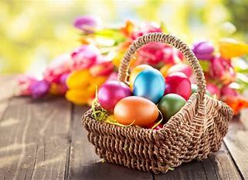
Class 11. Best Combination
Class 12. Ridden Coloured
Class 13. Thoroughbred
Class 14. M&M
Class 15. Veteran
Class 16. Open Horse
Class 17. Lead Rein
Class 18. First Ridden
Class 19. Novice Horse/Pony
Class 20. Novice Rider
Class 21. Fancy Dress
CHAMPIONSHIP

