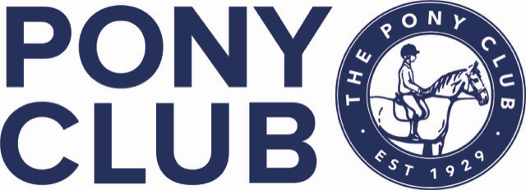

YORK AND AINSTY NORTH PONY CLUB
NEW YEAR SHOW JUMPING
Northallerton Equestrian Centre
4th January 2026
OPEN TO ALL PONY CLUB MEMBERS

CLASS 1 50cm clear round (assisted but no lead reins)
Kindly sponsored by Lizzy Peacock Animal McTimoney Practitioner lizzypeacock_17@yahoo.com
CLASS 2 55cm
Kindly sponsored by JYG Farriery Ltd jygfarriery@outlook.com
CLASS 3 60cm
Kindly sponsored by Hearts Boutique www.heartsboutique.co.uk
CLASS 4 70cm
Kindly sponsored by Derrings Kennels www.derringskennels.co.uk
CLASS 5 80cm
Kindly sponsored by TL Dallas www.tldallas.com
CLASS 6 90cm
Kindly sponsored by Wilson Close Ltd

Prizes kindly donated by marius-fabre – Luxury horse shampoo & leather care.
www.marius-fabre.com/en/161-horses

Class 1 £10 entry. Rosettes and sweets to all
Class 2 to 6 £15 entry. Rosettes to 6th Prizes in kind to third

Entries close 6pm 01\01\26 (or if full)
Times for all classes by 6pm 2nd January 2026
No refunds after close of entries.
RULES AND CONDITIONS
- All classes to be run under Pony Club Show Jumping rules 2025
- Classes 3 – 6 will be decided on a timed shortened course immediately after any clear round.
- Any horse/pony and rider combination can only enter 2 classes, excluding clear round.
- Correct dress should be worn
- Hats to correct Pony Club standard and tagged, and must be worn at all times when mounted
- The organisers do not accept liability for any loss or damage, injury or illness to any persons or property whatsoever.
- The organisers have taken all precautions to ensure the health and safety of everyone present at the event.
- The organisers reserve the right to alter or amend the schedule/rules at any time.
- The judge’s decision is final.
- Any queries/objections must be taken up within 30minutes of the class finishing with £20 cash deposit.
- No skipping out in the car park and please take all your rubbish home.


