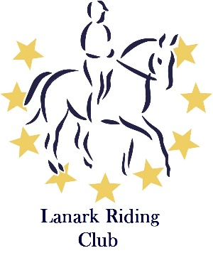
Lanark Riding Club
2017 Dressage League
8th October 2017
Stanmore Stables, Lanark, ML11 7RR
This event is kindly sponsored by Jodie Cassels
Equine Therapies

Class 1 Introductory C (2016)
Class 2 Beginners Preliminary 13 (2006) Combination to have no BD points nor have won any dressage competition at prelim or above pre-2017, nor to have previously won this league
Class 3 Open Prelimary 15 (2008) Combination may not enter class 1
Class 4 Novice 37 (2007) Combination may not enter class 1 or 2
Class 5 Elementary 40 (2010) Combination may not enter class 1, 2 or 3

Rosettes 1st to 6th plus highest placed junior. Highest placed members in each class are sponsored by McCaskie and will receive a McCaskie’s voucher and rosette
Entry fee £10 per class for members, £15 per class for non-members.
Pre-entries close on 30th September. Entries may be taken after this with a £4 late entry fee.
Times available from 5th October.
LRC and Stanmore accept no liability for accidents, damage, injury or loss to horses, owners, spectators or property whatsoever and entries are only accepted under this condition
Competition will run under British Dressage rules.
All competitors must have evidence of third party liability insurance available for inspection. Members of British Riding Clubs and Gold Card BHS members have this as part of their membership.
All Competitors must ensure that their riding hat conforms to current BRC standards.
NO DOGS ALLOWED

Lanark Riding Club Dressage 8th October

Class | Rider | Horse | LRC  member? | Junior?  (Under 18) | Entry  fee

I have read the rules and agree to abide by them.
Signed:
Name:
Address:

Telephone:
Email:
I have: BRC Membership BHS Gold Membership Public Liability Insurance
(Please circle as appropriate)
Payment: Cheque Cash BACS Paypal
(Payment can be made by cash, cheque, BACS or paypal. Cheques made payable to Lanark Riding Club.)
Entries to: Katy Westmore, 44 Newton Avenue, Barrhead, G78 2JY or email to lanarkridingclub@gmail.com
To pay via paypal visit: lanarkridingclub.co.uk/entries/
Highest placed member in each class sponsored by www.mccaskie.co.uk

