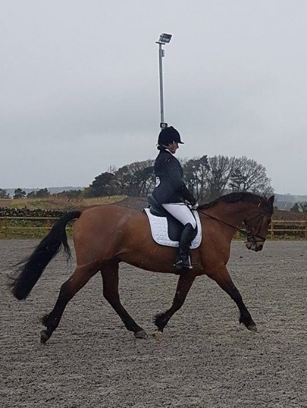
Lanark Riding Club
Test and Teach
21st October 2017
10am start, 30 minute sessions
Bluefaulds Farm, Bents Rd,
Chapelton, ML10 6SG

Come along and practice riding a dressage test with top tips from our judge Katy Westmore, ready to start our 2018 dressage league!
This months test are Intro A, Prelim 7 and Novice 24. Elementary available on request.
Each session will last approx. 30 mins. Ride your test, get 15 mins of feedback, then ride your test again!
Cost per session is £22 for members, £27 for non-members.
………………………………………………………………………....
Rider | Horse | Test being ridden | Junior? | Member?

Address:
Email:
Mobile:
Please complete the booking form and email to lanarkridingclub@gmail.com , who will confirm availability and payment details. Spaces are limited and will only be confirmed on receipt of payment.

