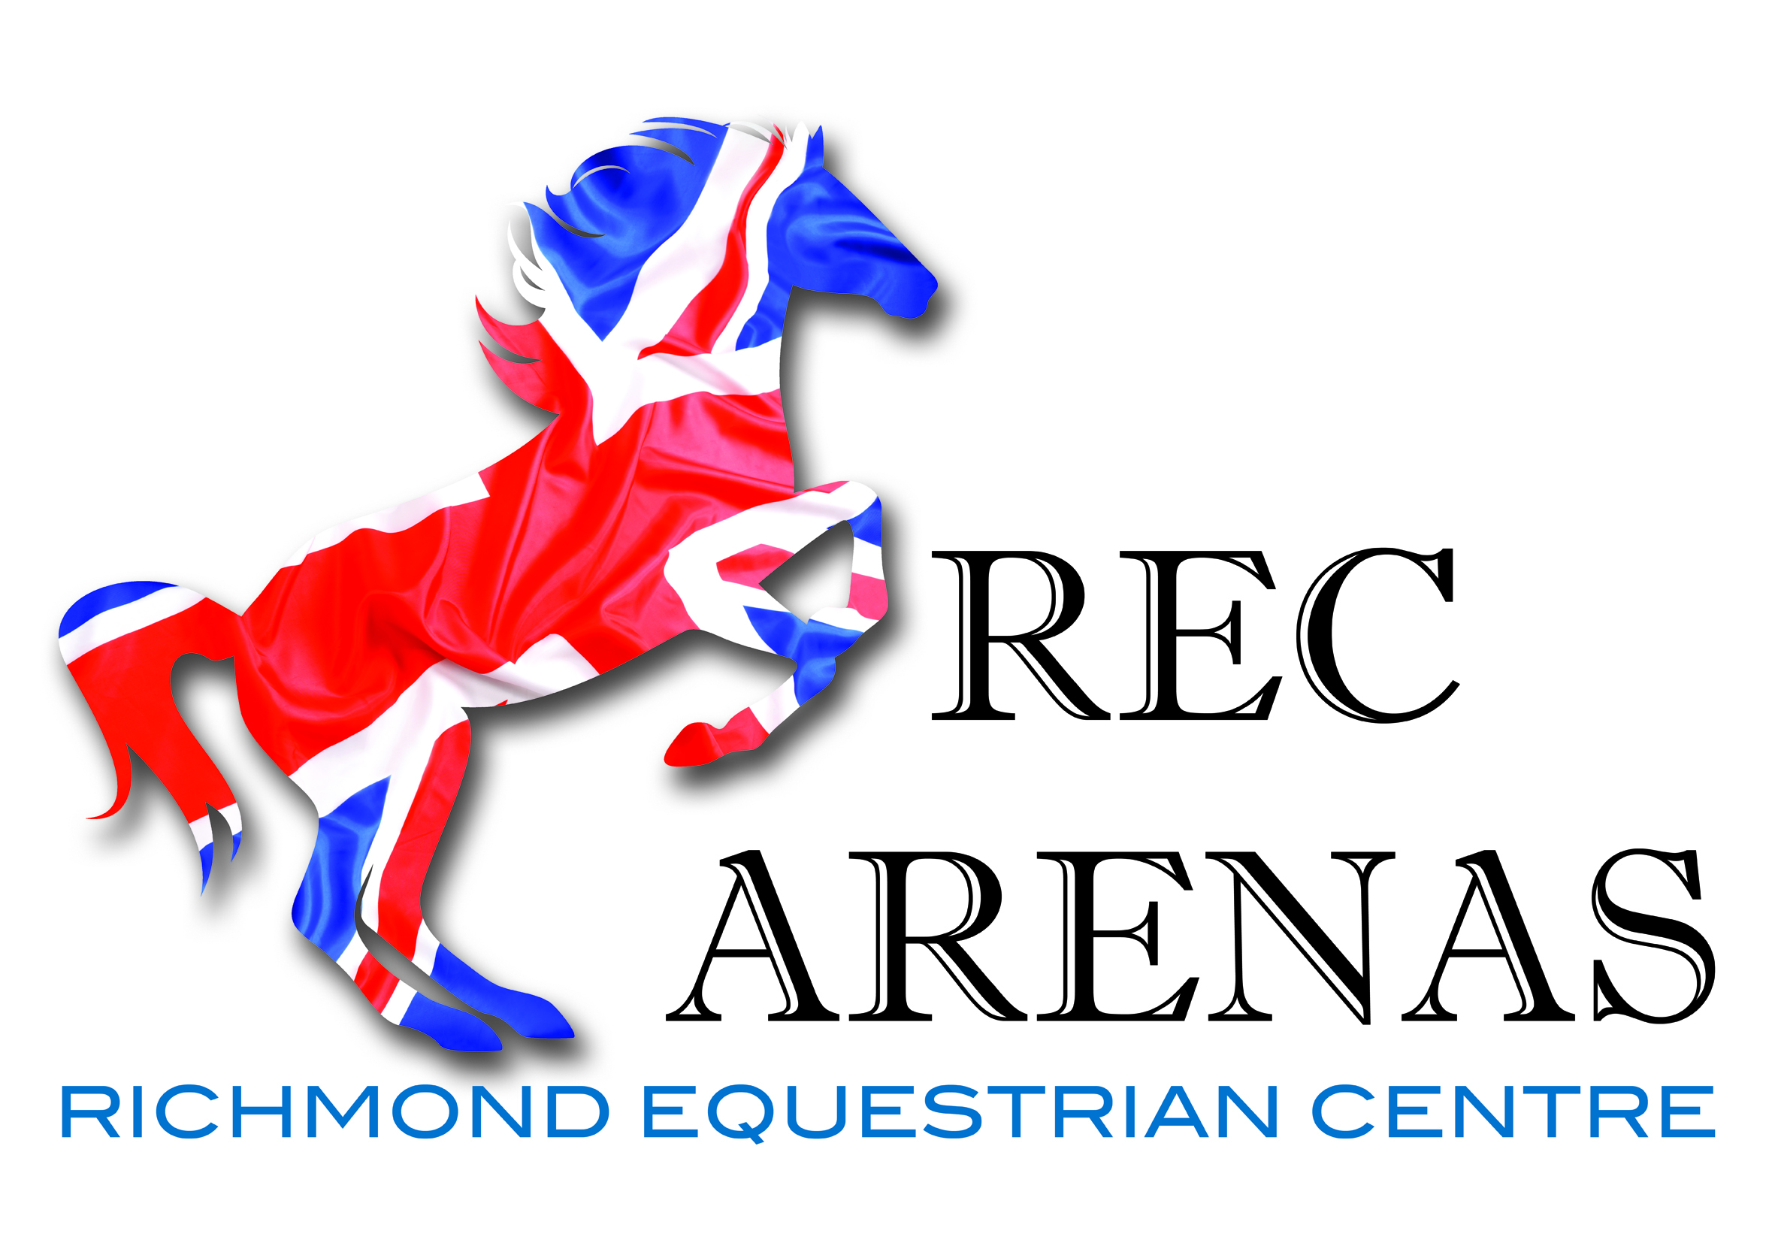

UNAFFILIATED EVENING SHOWJUMPING
ALTERNATE WEEKS OF HEIGHTS

13th OCT – 55, 65, 75 and 85cm

20th OCT – 85, 95, and 105cm

3rd NOV – 55, 65, 75 and 85cm

10th NOV – 85, 95, and 105cm

17th NOV – 55, 65, 75 and 85cm

1st DEC – 85, 95 and 105 cm

8th DEC – 55, 65, 75, and 85cm

15th DEC – 85, 95 and 105cm

22nd DEC – Xmas showjumping party 55, 65, 75 , 85 and 95cm

START 6PM WITH CLEAR ROUND - £5.00 no rosette or £6 with a rosette.
ENTRY FEE £8 PER CLASS OR 2 ENTRIES FOR £15

CLASSES START AT 6.30 PROMPT.

1st prize £10 if more than 5 in a class, 2nd prize £8 if more than 10, and 3rd prize £5 if more than 15 in the class. Rosettes to 6th.

ALL ENTRIES ON THE NIGHT

