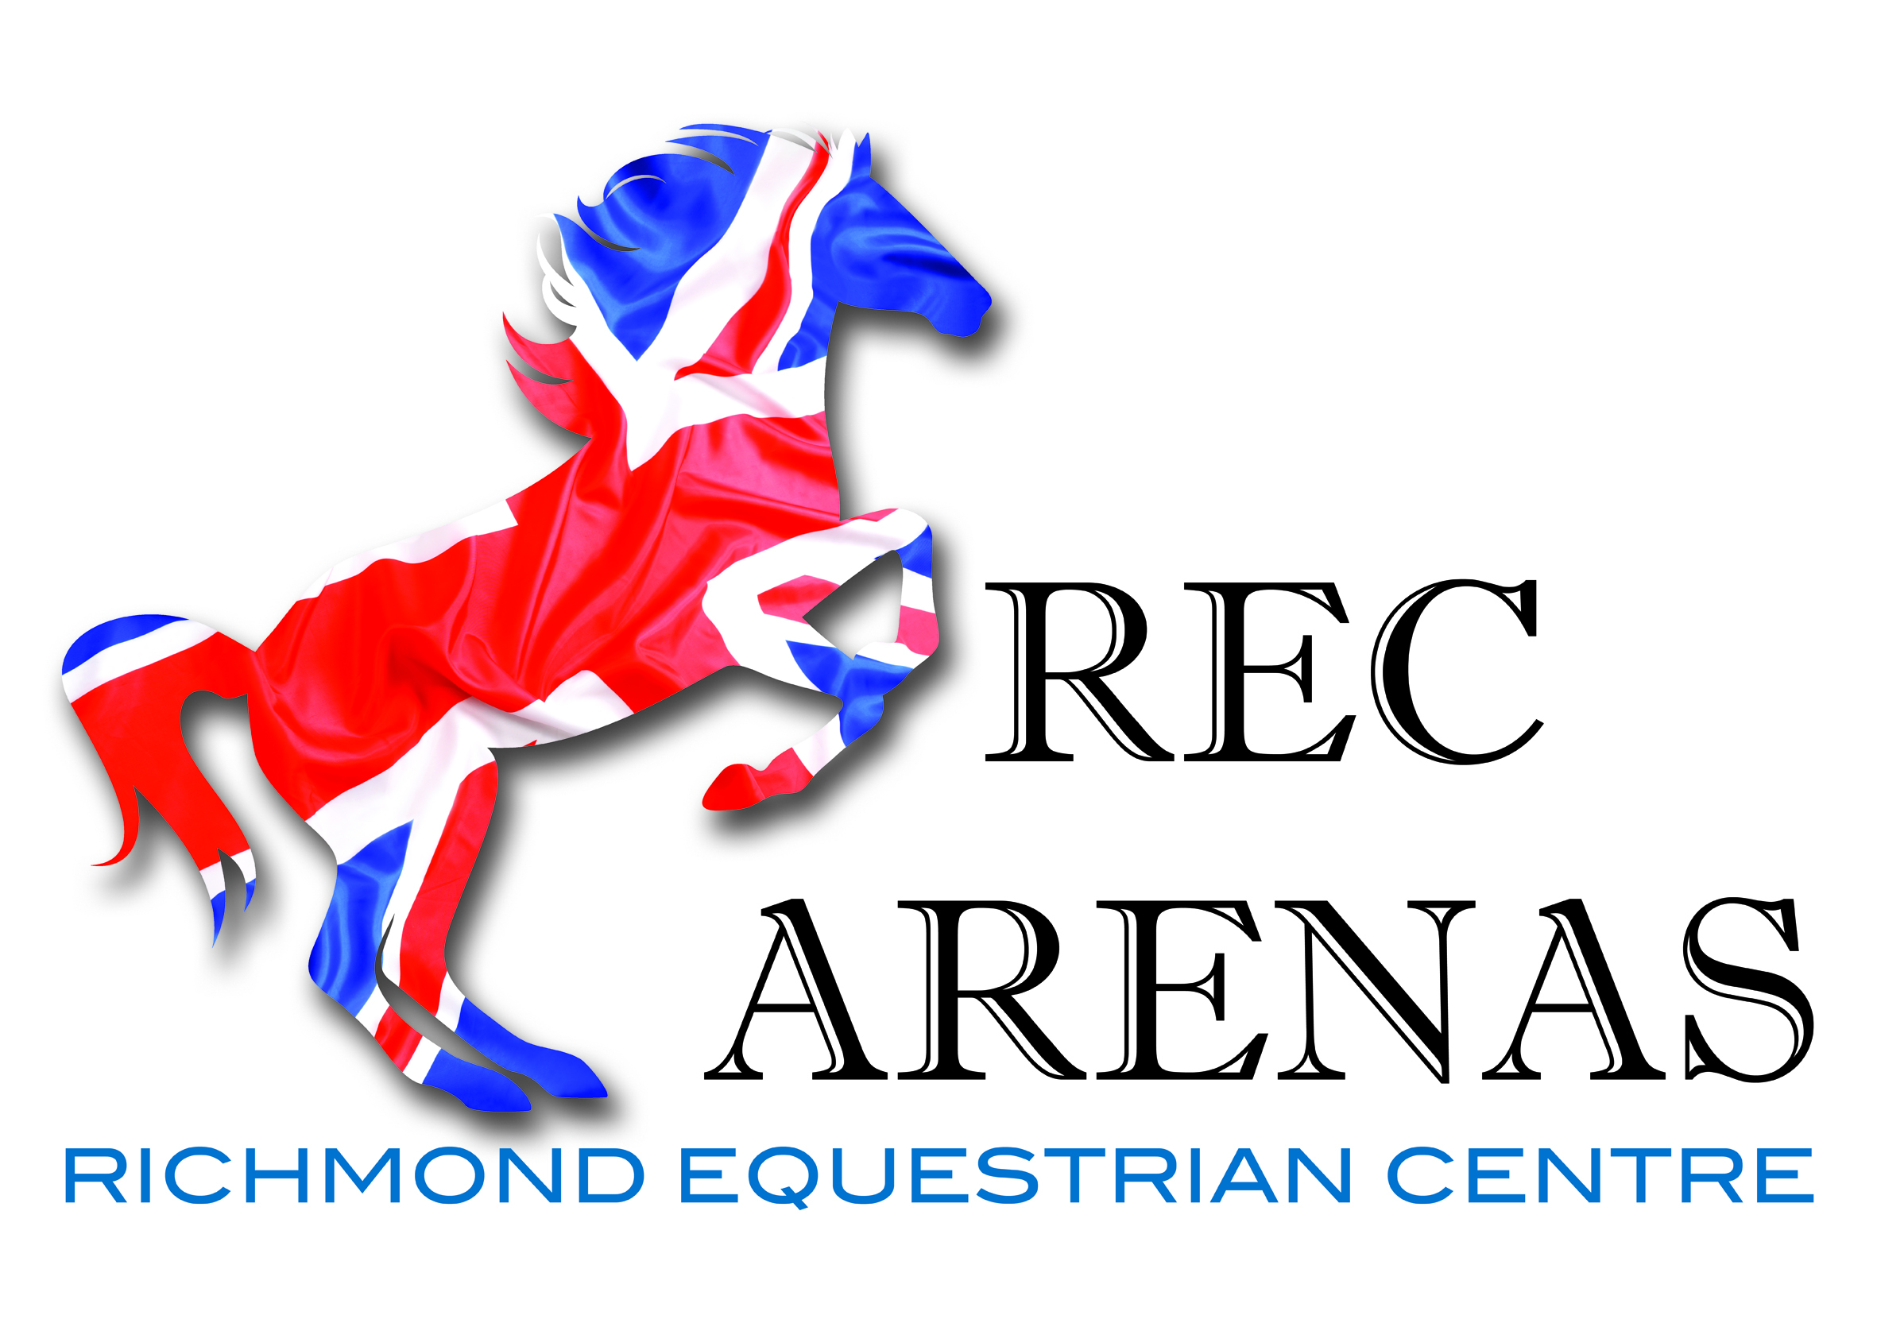
Unaffiliated Dressage
Winter league
Trailblazers qualifier, Club Quest 18th Feb, 4th March, and 23rd April. 3 Valleys RC League
Sun 20th November
Intro B, P1, P12, N24, N30 and any PYO inc BE short arena test
Sun 18th December
Intro A, P2, P13, N27, N34 and any PYO inc BE short arena test
Sun 22nd January
Intro C, P7, P14, N28, N30 and any PYO inc BE short arena test
Sat18th February
Intro A, P1, P12, N24, N34 and any PYO inc BE short arena test
Sat 4th March
Intro B, P2, P13, N27, N30 and any PYO inc BE short arena test
Sun 23rd April Winter League Final
Intro C, P7, P18, N28, N34 and any PYO inc BE short arena test
Entry Fee
1 test £12
£1 Discount for 3 Valleys RC Members. Please state on entries you are a 3 Valleys RC member
Times available on line at www.richmondequestriancentre.co.uk Fri prior to each competition.
To be run in conjunction with BD rules. Rosettes 1st to 6th.
Points will be awarded for Intro, Prelim and Novice to go towards the League table.
Points for League table
57% - 59.9% 1 point
60% - 63.99% 2 points
64% - 67.99% 3 points
68% - 69.9% 4 points
70% - 73.9% 5 points
1 extra point awarded for attending!
Rosettes and sashes for highest placed RC member
Sashes and Prizes awarded to the champion of each league Intro, Prelim and Novice on the 15th October

