Western Riding Clinic with Emma Chapman

Open to Members and Non Members

Saturday 21st January 2017

Hebden Wood Equestrian, indoor school
10.00am – 1.00pm (1 HOUR GROUP LESSON)
**NEW PRICE** £16 (members) & £20 (non members) **NEW PRICE**

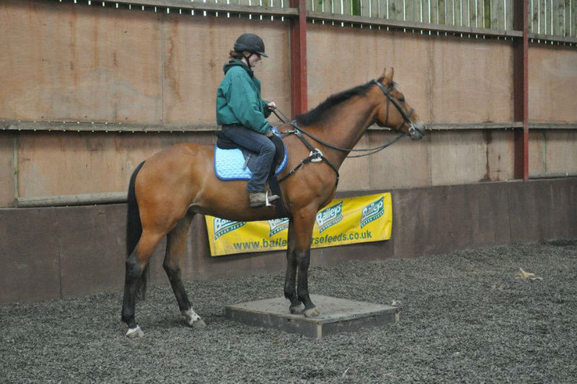A new clinic for 2017 based on the discipline of Western Riding, you don’t have to have a western saddle or be an expert, this is a taster session which will cover:
- Western aids and manoeuvres
- Reining
- Trail Obstacles (poles, gateways etc)
- Suppleness and strengthening of the horse
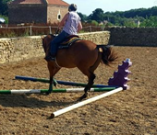

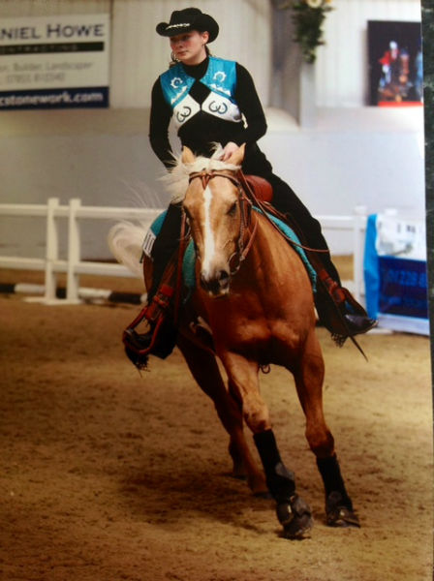The techniques used are very transferable and focus on suppleness, strengthen and harmonising the communication between horse ad jockey. So if you fancy something a bit different and want to work on flexing, suppleness and strengthening over the winter months this will give you some great tips.

Emma is a Western Equestrian Society Level 2 instructor, based at Cowling Hill Farm, Bedale.. Over the years Emma has also gained knowledge and skills in areas such as showing and Western riding. She regularly competes in Western and English classes on horses that she has trained. This goes to prove that her methods are not just trick training but in fact create willing and safe horses for any sphere of use. http://www.emmachapmantraining.co.uk/

Book via:
www.brimhamridingclub.co.uk
www.horsevents.co.uk
email jannataylor23@hotmail.com

