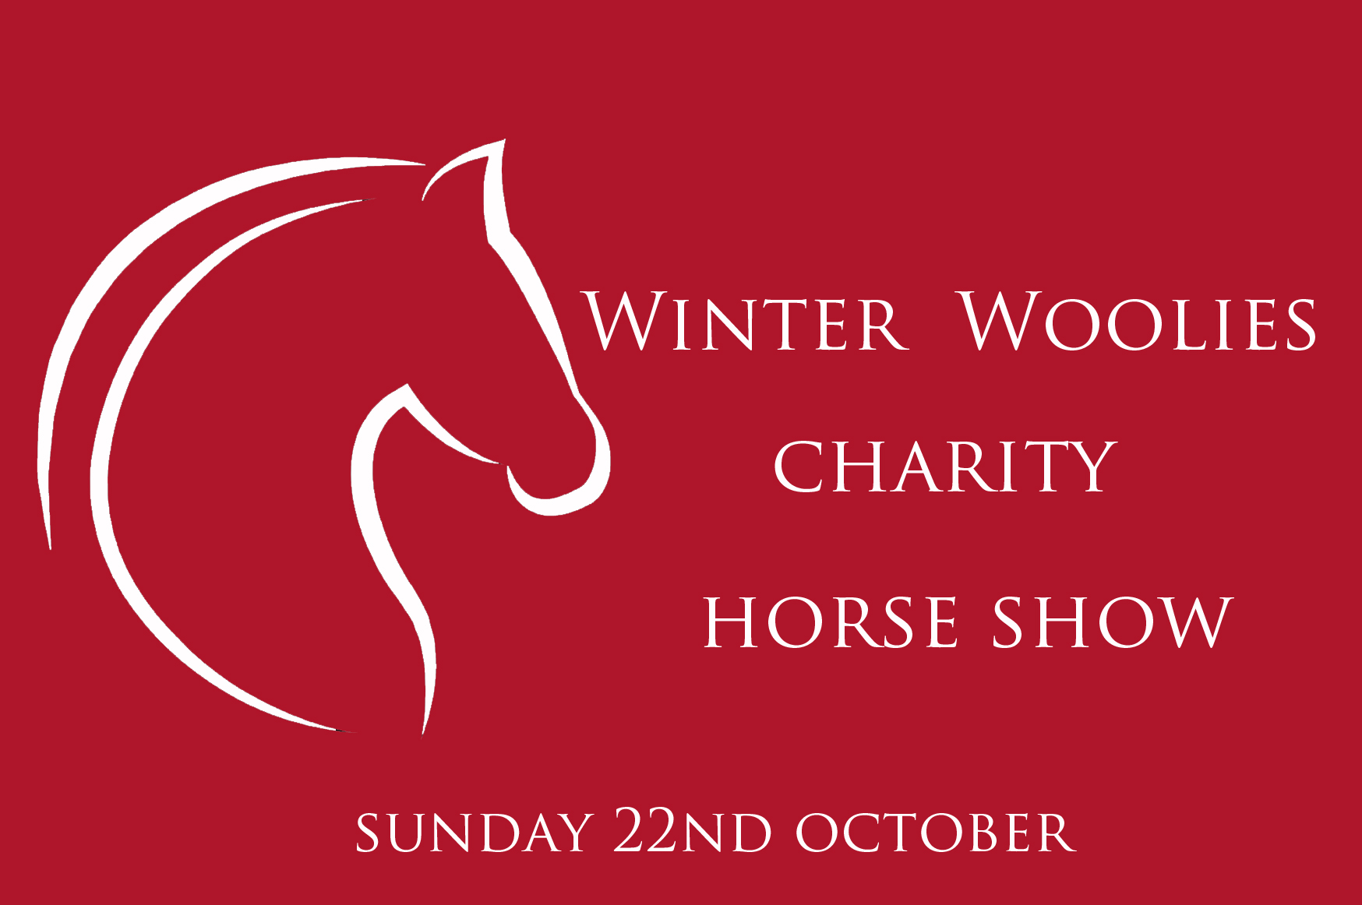

WINTER WOOLIES CHARITY HORSE SHOW

SUNDAY 22nd OCTOBER 2017

TRILEY FIELDS EQUESTRIAN CENTRE, ABERGAVENNY
By Kind Permission of Beccy Field

Address: Upper Triley Farm, Llantilio Pertholey, Abergavenny NP7 8DF

Show Organiser: Myscha Dene 07727 908 463
Email: myscha-dene@hotmail.co.uk
Find us on Facebook: Winter Woolies Charity Horse Show

Class Entries: £7.00 per class ONLINE £8.00 per class ON THE DAY
First aid: £3.00. Online entries CLOSE 18/10/17 Midnight.

A friendly show with classes for everyone from novices to the more experienced. Rosettes to 6th place in all classes with the exception of stallion classes which are rosettes to 4th. Fabulous sashes prizes and rosettes up for grabs in all sections!

There will be catering services on site from ‘Just Toasty’, The Tippsy Mare prosecco bar will be attending, and a Tack stall, all alongside an Equine Pix photography who will be printing on site for those wishing to buy photographs.

The Winter Woolies Charity Horse Show will be raising funds for The Maternity unit in Prince Charles Hospital Merthyr to enable the unit to provide a new bereavement room for families who have suffered the loss of a baby.

We would like to take this opportunity to say a huge thank everyone who has kindly contributed to the show either financially or by helping on the day. Your donations, sponsorship, and support are hugely appreciated.

9am Ring 1: In Hand Judge: Mr V.Moore

Class 1: M&M small breeds
Class 2: M&M large breeds
Class 3: Young stock (colt or filly under 3 years)
Class 4: Part bred
Class 5: Welsh section A’s & B’s (mare or gelding)
Class 6: Welsh section C’s & D’s (mare or gelding)
Class 7: Veteran (15 years and over)
Class 8: Young Handlers (12 years and under)

IN HAND CHAMPIONSHIP for all 1st and 2nd placed exhibits from the in hand section. Champion to receive the Robert Robinson Memorial Cup along with a sash rosette and prize. Reserve in hand champion to receive rosette, sash and prize.

Kindly sponsored by Ty Blodyn Stud

BRIDFA STUD AWARD- Judges will also be selecting the best Gelding to receive the Bridfa Guevara Stud CHAMPION GELDING AWARD.

Ring 1: Stallion Classes Judge: Mr V.Moore

Class 9: In hand Stallions Welsh A & B
Class 10: In hand Stallions Welsh C & D
Class 11: Ridden Stallion (rider must be 15 years old or over as of January 1st 2017)

STALLION CHAMPIONSHIP - All 1st & 2nd place stallion exhibits from classes 9 10 & 11 to come forward. Champion stallion to receive The Bobi-phiel memorial fund cup, rosette, sash and prize. Reserve champion stallion to receive sash rosette, and prize.

Kindly sponsored by Dreamscape INK & Tryfel Stud
Not to commence before 12:00 - Ring 1: Restricted Ridden Judge: TBC

Restricted Ridden Rules: Horses/Ponies entered not to have qualified for HOYS, RI, Olympia and not to have won at county level or more than three firsts at local level. Rules will be strictly adhered to, in order to ensure all competitors receive fair opportunity.

Class 12: Restricted lead rein (rider 9 years and under)
Class 13: Restricted first ridden (rider under 12 years)
Class 14: Restricted M&M small breeds
Class 15: Restricted M&M large breeds
Class 16: Restricted Novice horse or pony

MINI RESTRICTED RIDDEN CHAMPIONSHIP for all 1st & 2nd placed exhibits from classes 12 & 13 to come forward. MINI CHAMPION to receive the RR MINI Championship silver cup, sash, rosette and sweetie bouquet. Reserve MINI CHAMPION to receive sash, rosette and prize.

SENIOR RESTRICTED RIDDEN CHAMPIONSHIP for all 1st & 2nd places exhibits from classes 14,15 & 16 to come forward. Senior RR CHAMPION to receive the RR SENIOR CHAMPION silver cup, rosette sash and prize. Senior RR Reserve Champion to receive rosette sash and prize.

Kindly sponsored by Abergavenny Tyres.

Ring 1: Home Produced Ridden- Judge: TBC

Home produced exhibits are to be horses/ponies who are genuinely home produced by their owner within the family for no profitable gain.

Class 17: Best turned out
Class 18: Home produced lead rein (rider 9 years and under)
Class 19: Home produced first year first ridden (rider under 12 years)
Class 20: Home produced mare
Class 21: Home produced gelding
Class 22: Home produced Novice horse or pony
Class 23: Pony club pony
Class 24: Ridden Veteran (Winner to receive trophy & sash sponsored by Gail Morris)

HOME PRODUCED CHAMPIONSHIP for all 1st & 2nd placed exhibits in all home produced classes to come forward. Home produced CHAMPION to receive the Winter woolies home produced silver cup, sash rosette and prize. Reserve home produced champion to receive sash, rosette and prize.

Kindly sponsored by Performance Ponies

Ring 2 Indoor Arena: Open Ridden Judge: TBC

Class 25: Open lead rein M&M (rider 9 years and under)
Class 26 : Open lead rein Plaited (rider 9 years and under)
Class 27: Open first ridden (rider under 12 years. Pony plaited or unplaited)
Class 28: Open M&M small breeds
Class 29: Open M&M large breeds
Class 30: Open part bred
Class 31: Open coloured
Class 32: Ridden Cob
Class 33: Ridden Hunter

MINI OPEN RIDDEN CHAMPIONSHIP
For 1st & 2nd place exhibits from classes 25,26 & 27. Our MINI OPEN RIDDEN CHAMPION will receive a fantastic Bespoke Rosettes rosette, a sweetie bouquet, sash and the Open ridden silver cup kindly sponsored by The Suntrap, Abertillery.

SENIOR OPEN RIDDEN CHAMPIONSHIP For all 1st and 2nd places exhibits from classes 28-33. Open ridden SENIOR CHAMPION to receive the Tomath Stud Silver cup, sash, rosette and prize. RESERVE CHAMPION to receive the Tomath Stud sash, rosette and prize.

Kindly Sponsored by Tomath Stud.

Ring 1: Novelty Section Judge: TBC

£5 per class

Class 34:Pony with the prettiest face
Class 35: Blemished but cherished
Class 36: Fancy dress

NOVELTY CHAMPION to receive the Novelty Champion silver cup, ribbon and sweetie bouquet.

Kindly sponsored by Jos Fell

SUPREME CHAMPIONSHIP

RING 2- Indoor Arena

MINI OVERALL SUPREME OF SHOW to include all CHAMPION & RESERVE CHAMPION exhibits from ALL MINI RIDDEN CHAMPIONSHIPS throughout the show, with the exception of Novelty Classes.

SENIOR OVERALL SUPREME OF SHOW to include all CHAMPION & RESERVE CHAMPION exhibits from ALL SENIOR RIDDEN CHAMPIONSHIPS throughout the show.

MINI SUPREME CHAMPION to receive a flower garland sash, rosette and sweetie bouquet along with the MINI SUPREME CHAMPION silver cup. RESERVE MINI SUPREME to receive sash, rosette and prize.

SENIOR SUPREME CHAMPION to receive a huge flower garland sash, rosette, prize and the winter woolies supreme champion cup. RESERVE SUPREME CHAMPION to also receive a sash, rosette and prize.

Kindly sponsored by White Horse Farm Livery Yard, Abergavenny.

Many thanks to all our generous sponsors, supporters and donators;

- The Park hotel Pandy
- Abergavenny Tyres
- RM Jones Abergavenny
- Tomath Stud- The Carter Family
- Ty Blodyn Stud- The Flower Family
-Tryfel Stud- The Cobley Family
- Bridfa Guevara Stud
- Tarnya Sheilds, The Suntrap Abertillery
- Pretty miss beauty & nails, Abertillery
- Performance Ponies- The Eynon & Faulkner Family
- Williams Country Supplies Merthyr
- Keepers Feeds, Blaenavon
- White Horse Farm Livery Yard
- Bespoke Rosettes, West Midlands
- Jos Fell & Family
- Gail Morris & Family
- Hannah Walters & Family
- Nic Edwards & Family
- Dreamscape INK
- Monica Knox & Family
- Amy Sevenoaks & Family
- Jo Holland & Family
- Hattie Thomas & Family
-Jayne Hamer & Family

IF ANYONE WOULD LIKE TO DONATE, OR SPONSOR ANYTHING FURTHER, PLEASE DO NOT HESITATE TO CONTACT US. MEMORIAL TROPHIES AVAILABLE FOR THOSE WISHING TO SPONSOR A TROPHY IN MEMORY OF A LOVED ONE.

Rules:

- Correctly fitted hard riding hats are to be worn, and correctly fastened at all times whilst mounted and whilst showing in hand. Hats must be in accordance with current British standard.

- Triley fields equestrian centre and Winter Woolies Charity Horse Show excepts no responsibility for any theft, damage, loss, accident, illness or injury to any property, person or animal attending the event.

- Every effort has been made to ensure the well being and safety of all involved and attending this event. In order for the measures taken to be effective rules, and instructions should be followed at all times.

- Please take your litter home with you or dispose of it in appropriate bins and please do not clean your lorry/horsebox out on site.

- Horses/Ponies are not to be left unattended at horseboxes or lorry’s. Please ensure all horses/ponies are securely tied up.

- The Judges decision is final. Anyone wishing to contest should do so to the show staff at the secretary within one hour of the class completion.

- Class rules for Restricted & Home produced sections will be strictly adhered to in order to ensure there is fair chance and opportunity for all supporting the show. Please enter with integrity.

- Novice classes are for ponies/horses very new to being under saddle or showing. These ponies are not to have competed at county level or won more than 3 firsts at local level. Walk, trot, canter optional, lead rein permitted.

- Lead rein ponies must be ridden in a snaffle bit. A wilkie is acceptable. Lead reins must be directly affixed to the noseband and not through the bit.

- No horses/ponies under 4 years of age are to be entered into the ridden sections.

- It is competitors responsibility to ensure they arrive with their exhibit at the ring on time.

- Those handling or riding stallions must be 15 years old as of the 1st of January 2017 in accordance with showing rules.

